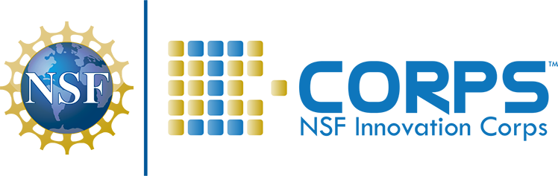
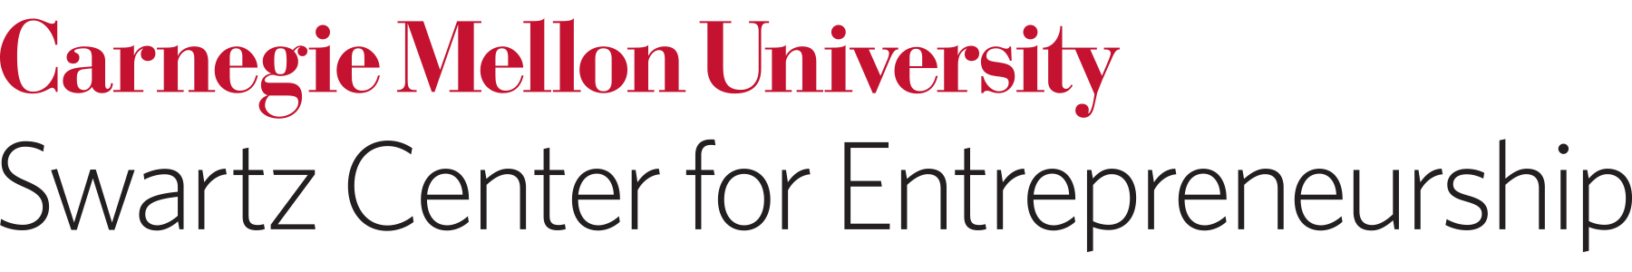

I-Corps funds are intended for CUSTOMER DISCOVERY activities. Costs associated with prototype development after meaningful customer discovery has been performed are also permitted. If you have any questions about permissible reimbursements, before purchasing, contact Melanie Simko (msimko@andrew.cmu.edu).

YES: I can be reimbursed for…

1. Domestic industry trade shows and conferences with networking component
- Registration fees
- Round trip domestic economy airfare (no upgrades or trip insurance can be reimbursed)
- Lodging
- Mileage
- Rental car
- Transportation to and from airport (Uber, Lyft, taxi, bus, etc)

2. Prototype development
- Equipment and parts
- Certain specialized software
- Lab reagents and supplies

3. Miscellaneous
- LinkedIn premium membership for team entrepreneurial and/or technical lead for duration of the cohort (3 months)
- web hosting fees

NO: I can’t be reimbursed for ….

- Conference fees to present research or research papers.
- Common hardware or general office software: laptops/desktops, tablets, phones, printers, Adobe, Microsoft office, etc.
- Payroll for team members, interns, etc.
- Professional consultation, such as legal services, accounting, marketing, patent costs, grant writing
- Incentives for customer surveys
- Food and alcohol
- Advertising
- Inventory

