Government-to-University Pittsburgh
Public Service Project
Interim Report
July 28, 2021

Introduction
In January 2020, Carnegie Mellon University’s Metro21: Smart Cities Institute, in collaboration with Heinz College of Information Systems and Public Policy, was chosen to lead the Volcker Alliance’s Government-to-University Regional Coalition in Pittsburgh (G2U PGH). The original goal of the G2U initiative was to catalyze a robust local marketplace to sustainably connect government’s hiring and research needs with local university capacity. We are pleased to report that Metro21 has surpassed the project’s original goals laid out in our original proposal and detailed in this report and accompanying Appendix:
- Metro21 will apply its knowledge of intelligent systems and their faculty, staff, students, and peer networks to recommend innovative solutions;
- Serve as the primary coordinator of G2U program activities and be the Pittsburgh region’s primary liaison to the Alliance;
- Collaborate with the Alliance and Heinz College and curate the Regional Steering Committee, who will contribute to building structured regional networks between governments and universities;
- Organize, develop, and host in-person and online convenings of the Steering Committee on a regular basis (expected to be quarterly); in-person meetings are expected to be hosted at the Heinz College;
- Work collaboratively with the Alliance to publicize the work of the G2U initiative in Pittsburgh; and
- Travel, as needed, to connect/collaborate with other G2U regions and/or the Alliance.

Core Accomplishments
At the beginning of the project, Metro21 launched the Steering Committee of G2U PGH to provide strategic guidance to address the core issues effecting the supply of university student talent into careers in public service. Steering Committee members included a diverse representation of the Southwestern Pennsylvania region’s universities and government agencies (local, state, and federal). From the beginning, G2U PGH focused on pursuing opportunities to better prepare and strengthen the pipeline of talent from local universities into government and explore approaches to systematizing research exchanges focused on solving pressing government operational and management issues. Based upon feedback from the Steering Committee, it was determined that the best way to address the talent pipeline issue was to focus on two issues:
- Hold “Intel Sharing” convenings between career services and government hiring managers – to increase awareness of the value and full spectrum of job opportunities in government among college and university students and recent graduates in the Pittsburgh region.
- Launch a Public Service Messaging Campaign – to provide university career services leaders and government hiring managers with the information needed to guide students through successfully finding and applying for government jobs.
Two distinct working groups (Intel Sharing and Messaging) were formed to guide and advise the activities of the initiative/project. Currently, the Steering Committee and Working Group include 45 participants, including 22 from seven government agencies and 23 from six universities. These volunteers have dedicated themselves to help guide and inform the G2U PGH and we are grateful for their support, especially from our co-chairs of the working groups (Messaging: (Sharon Mickens and Joy Ruff and Intel Sharing: Laura Zaspel and Linda Loewer). Since inception of this project, we have held 22 meetings with our Steering Committee and working groups - all but the first were virtual, in response to the COVID-19 pandemic. While the pandemic provided numerous challenges to the original goals of this project (for example, no in-person convenings), it provided a great forum for discussion of the challenges facing both universities and government agencies throughout each stage of pandemic that we feel has helped the talent pipeline for public service careers to be more resilient, sustainable, diverse, and equitable.

Public Messaging
The social media platform, Instagram, provided a way to connect with job seeking university students and engage our network with interactive polls and public sector career spotlights.
G2U PGH Instagram:
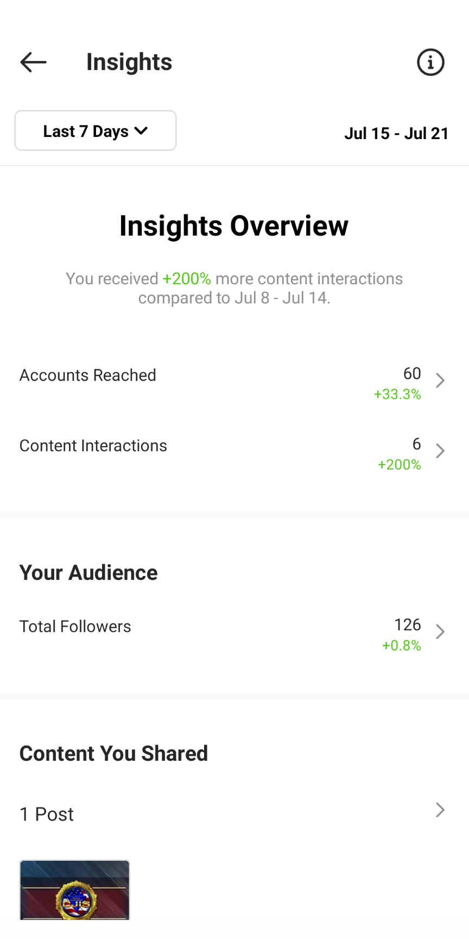
The goal of this project was to rebrand public service in the eyes of current and future university students, most of whom primarily use Instagram. In the short-run, success looks like engagement – likes, comments, and discussion on social media. Long-run success will see an increased number of students pursuing careers in public service, especially in areas of high need identified by G2U PGH.
We feel very confident that at the mid-way point of this project we have achieved moderate success. Since launching the G2U PGH Instagram account on February 15, 2021, we achieved the following accomplishments (as of July 23, 2021):
Instagram Analytics and Outcomes
- 126 Organic Followers
- 1,400+ Video Views
- 1,000+ Clicks (post interactions)
- 6,700+ Impressions

Intel Sharing
Guided by the input of its working group, Metro21 provided several touchpoints for Intel Sharing between career services leaders and government hiring managers with the information needed to guide students through successfully finding and applying for government jobs, specifically through these three very successful webinars:
- "Matching High-Need Government Jobs with Highly Skilled Students."
- "Matching Students to Careers in Public Health and Social Services."
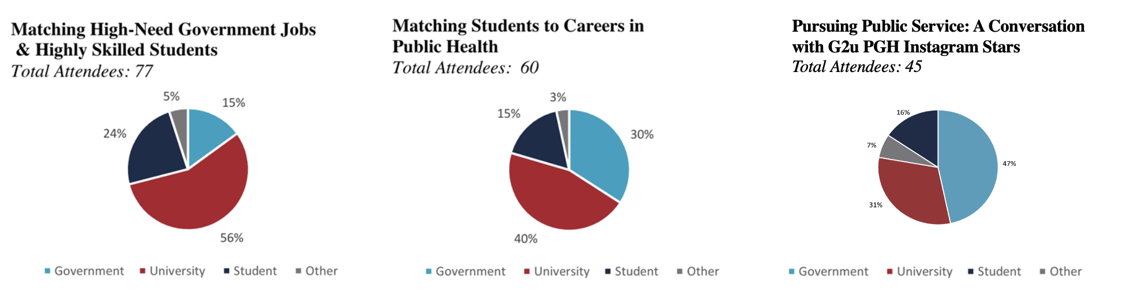
- Pursuing Public Service: A Conversation with G2U PGH Instagram Stars."

Community Response to Our Core Accomplishments
Through an interactive benchmark survey that polled our Steering Committee and working group members, we captured feedback on our project’s success:
- 100% of responses said G2U PGH has helped better connect the region’s talent in universities with careers in public service
- 75% of responses indicated being a part of G2U PGH has helped them connect with new people or organizations
- 92% of responses said being a part of G2U PGH helps with their organization’s mission

Testimonial highlights include:
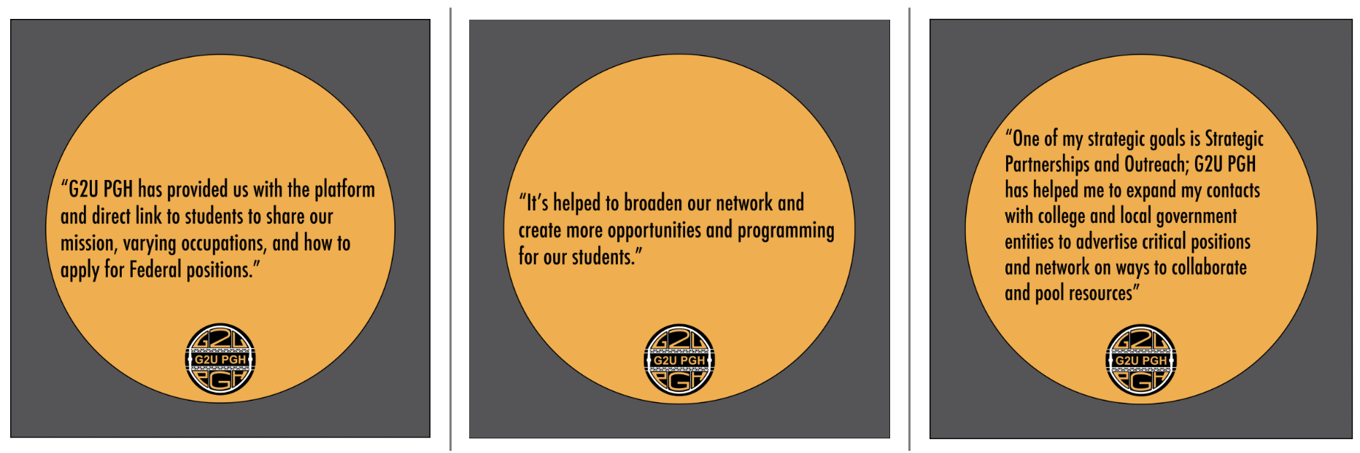

Unanticipated Challenges
- The COVID-19 pandemic was by far the biggest challenge to this project. With the shutdown of all in-person events and hiring freezes at nearly all government agencies, it forced the group to re-evaluate its mission and work collaboratively to provide insight and value, both short- and long-term for university career agencies and their students, as well as government agencies.
- Each government entity promotes and advertises their career opportunities on various job hosting platforms which makes it challenging to centralize and point students to a central location for job opportunities.
- Many public sector entities have not broken into the Instagram social media platform, making it difficult to directly connect students with our government partners on one application.
- Students and employers experienced Zoom fatigue at the culmination of the school year.

Lessons Learned and Potential for Expansion
- Students and employers use various social media platforms to promote their organization, events, and career opportunities. We have narrowed it down to LinkedIn as the best platform for sharing and connecting potential job seekers with career opportunities, while Instagram is best for sharing personal anecdotes and career tips through videos and interactive graphics.
- Connecting with the national G2U network and national public sector networks will allow us to advertise job opportunities to students outside the local Pittsburgh area.
- Providing a recording of our webinars allowed the group to reach a wider audience. as students and employers could revisit or re-watch our panel discussions on demand at a time that was convenient for them.

The Future of G2U PGH Messaging
- G2U PGH LinkedIn Launch
  - LinkedIn is a social media platform for job seekers, professionals, and businesses aimed at connecting job seekers to jobs to grow their careers.
- How LinkedIn is different from Instagram:
  - The tone and type of content style is different for LinkedIn and needs new post creations to resonate with the audience and build community.
  - A few post formats from G2U PGH Instagram can be repurposed on LinkedIn as well.
  - It is a direct platform for job and event posts and enables us to tag our Stars and government bodies for significant organic outreach.
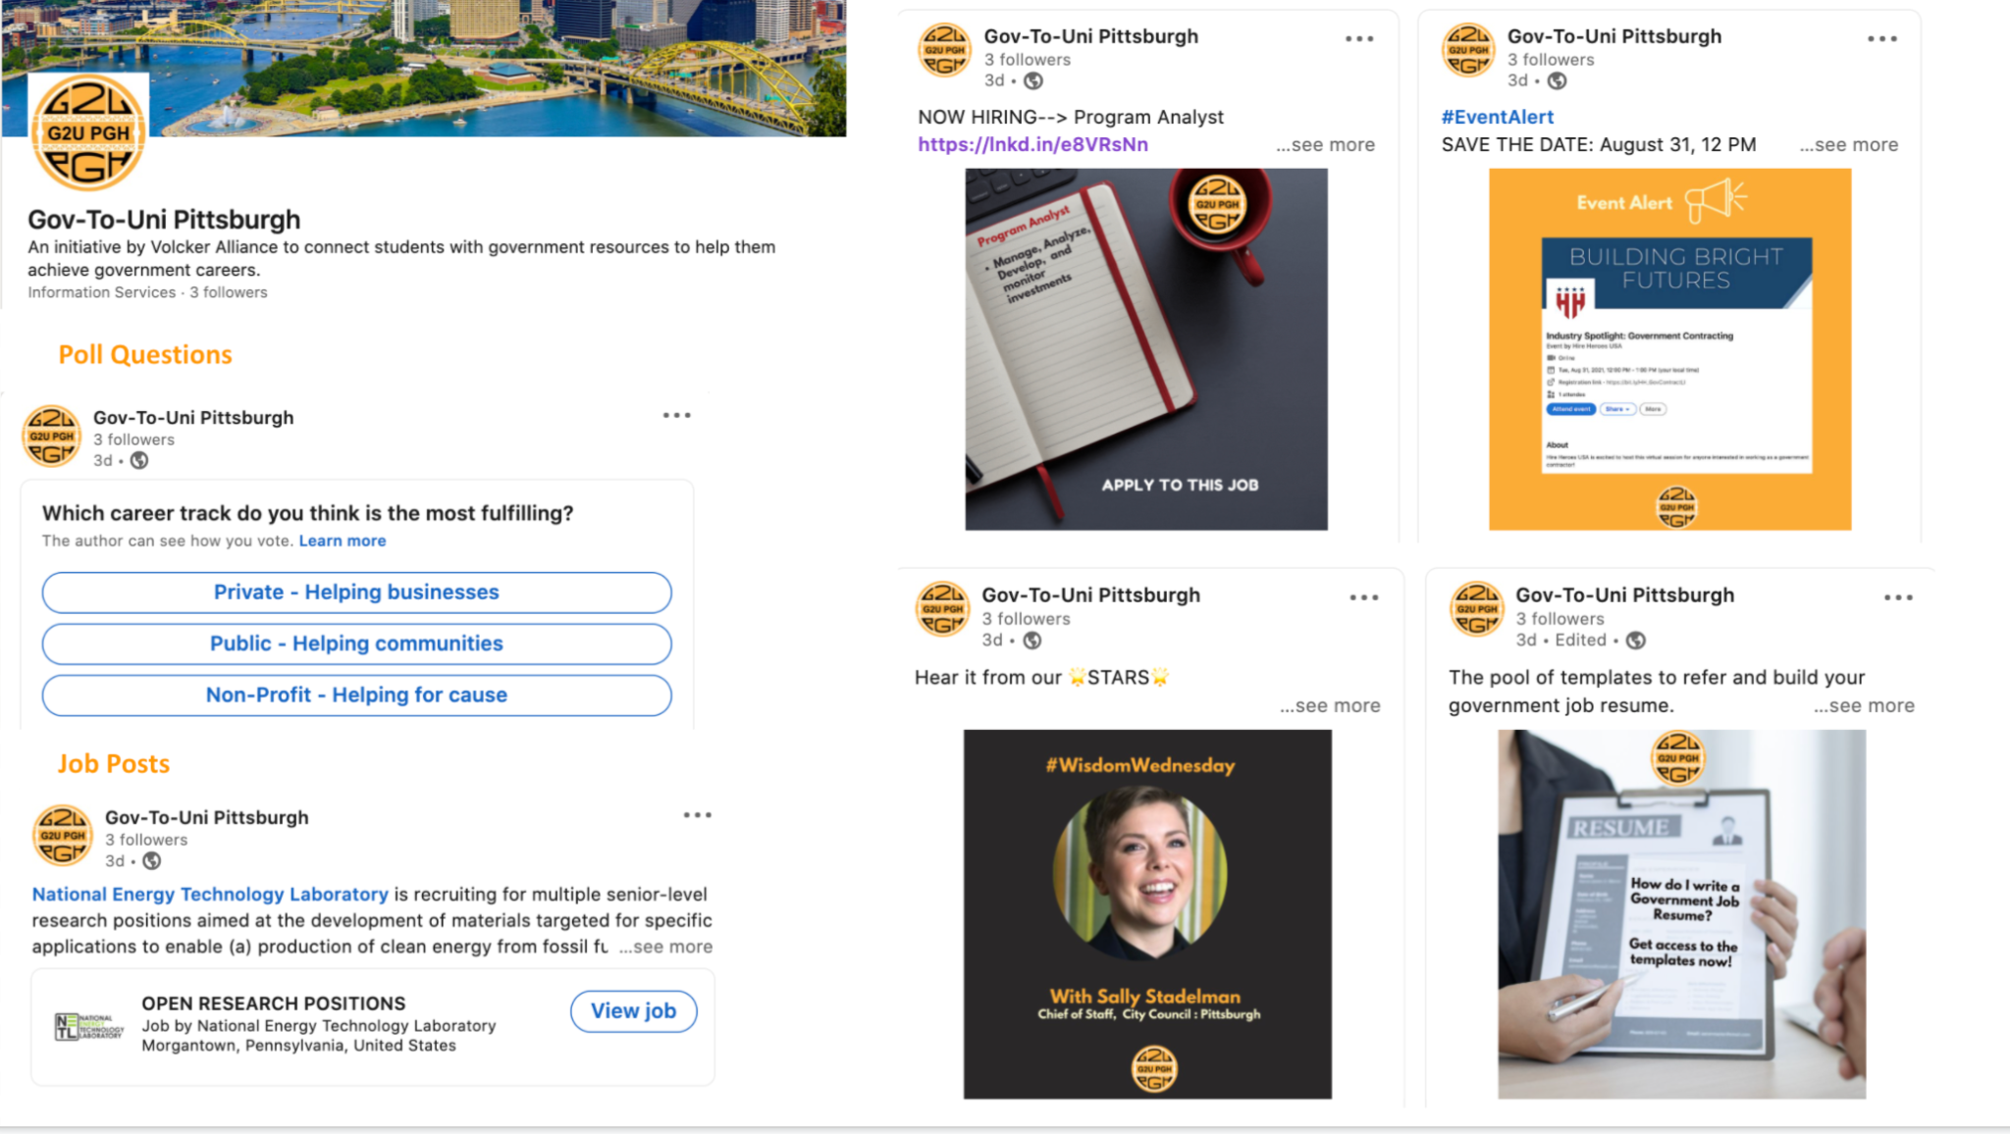

Conclusion and Next Steps
We are grateful for the support from the Volcker Alliance to support this important work and look forward to working with our key stakeholders and partners to ensure the longevity and sustainability of the project by helping to ensure a smooth transition to its next phase. Starting July 1, 2021, Metro21 will take the next six months to help guide and assist in the transition of the program to a new leadership model, whereby the Graduate School of Public and International Affairs (GSPIA) at the University of Pittsburgh and Heinz College at Carnegie Mellon University co-lead the next iteration of G2U PGH. The mission of the G2U directly aligns with the missions of both GSPIA and Heinz, making this model ideal for the next phase of the G2U PGH initiative. Following agreement on the transition and roles of the two organizations, Metro21 intends to follow a blended model of a transition strategy which would entail the activities listed in the project plan that has been provided to the Volcker Alliance in previous correspondence.

Appendix

- G2U Project Update Report (April 2021)

- Instagram Overview G2UPGH (April 2021)

- G2U PGH Whiteboarding Session (June 2021)

- G2U PGH Intel Sharing Webinars
  - Matching High-Need Government Jobs with Highly Skilled Students
  - Matching Students to Careers in Public Health and Social Services
  - Pursuing Public Service: A Conversation with G2U PGH Instagram Stars
- G2U PGH Steering Group and Working Group Members
  - Meeting dates
  - Groups by G & U

