G2U PGH Public Service “Day in the Life” project
Final Report
Submitted by Metro21
November 17, 2021

This final report is a summation of the achievements of the Government-to-University Pittsburgh (G2U PGH) Public Service “Day in the Life” project, generously supported by the Volcker Alliance’s Volcker Fund for the period of performance November 1, 2020 – October 31, 2021.

Background
This project sought to support the overall mission of G2U PGH: to help build the pipeline of talent to careers in the public sector. The goal of this project was to rebrand public service in the eyes of current and future university students, most of whom primarily use Instagram. As described in the interim report on April 30, 2021, in the short-run, success looks like engagement – likes, comments, discussion on social media. Long-run success will increase number of students pursuing careers in public service, especially in areas of high need identified by G2U PGH. We originally laid out these metrics to measure our success:
- Page Followers
- Page Visits
- Clicks on the Link in the Bio
- Impressions and Accounts Reached
- Likes, Video Views, and Comments
- Challenge post counts and reshares
Accomplishments
Since the birth of our Instagram profile, our audience base has continued to expand. More importantly, our followers have shown increased interaction times with our account. We have seen improved engagement with our page through the implementation of posts that focus on advertising upcoming professional development opportunities hosted by public sector entities (Figure 2a) as well as regular features highlighting new career opportunities (Figure 2b).

Highlights of our accomplishments include (Figure 1):

- 146 new accounts reached – an
increase of 440%
- 23 more accounts regularly engaged
- 2.3% increase in follower base
  - 29 new followers earned
  - 132 followers in total
- 3-minute increase in content
interactions
- 96.2% more accounts connected
through hashtags and Instagram
follower network
- 35 unique, first-time profile visits
Figure 1. A snapshot of @G2U_PGH Instagram page’s analytic overview highlighting accounts reached, unique profiles engaged, and follower growth

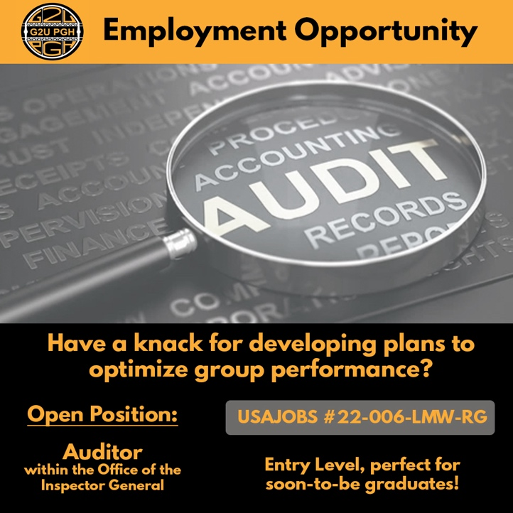
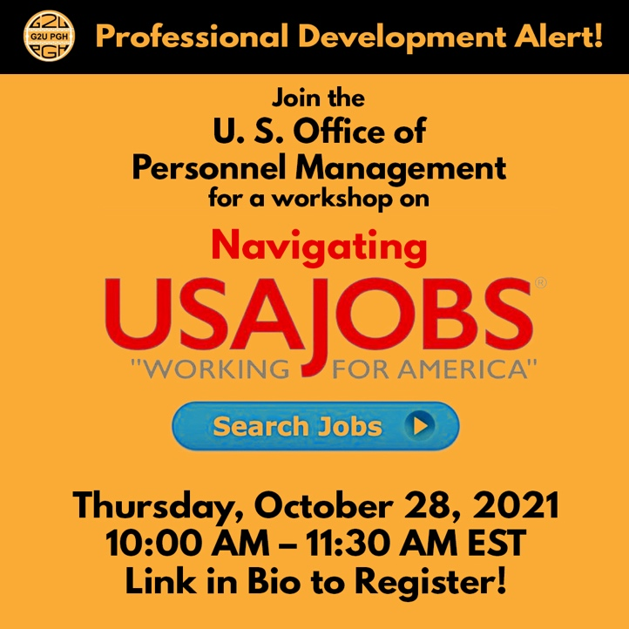

Figure 2a (Left) & Figure 2b (Right): Left: An example of a post that focuses on advertising upcoming professional development opportunities. Right: An example of a post that focuses on advertising upcoming job opportunities.

We received feedback from our working group and steering committee throughout the process. The minutes and summaries of our meetings can be found in our BOX folder which houses all of our project assets and supporting documentation. To capitalize on follower-based interest and need, as well as in response to the changing employment landscape as the region emerged from the COVID-19 pandemic, we chose to expand our network to reach users on a more professional and career centered platform, LinkedIn. Our launched LinkedIn page serves as a more direct pathway to connect job seeking college students and public sector employers (Figure 3).

Figure 3: The layout of our newly launched LinkedIn page.

Through LinkedIn, we can link our followers directly with public service career professionals through direct messages or tags on their LinkedIn profile or within our posts (Figure 5). In addition, we can utilize our expansive Metro21 network to reach a larger network of public sector professionals – a connection we were unable to make on Instagram due to the lack of public sector profiles on Instagram. Initial subscriber statistics from our page highlight the wide variety of industry professional fields connected in public service work (Figure 4). Using this diversity, we aim to reach and match a wider array of job-seeking collegians with public sector careers.

Figure 4. A summary of diverse follower career demographics.

Figure 5. Analytics of non-followers (unique viewers) that have been reached through direct tagging.

Initial LinkedIn Page Subscriber Statistic highlights (Figure 6):

- Total page subscribers: 26
- Total page viewers: 56
- ~20 unique page viewers per month
- Public Sector industries reached:
  - Public Policy
  - Research
  - Biotechnology
  - Telecommunications
  - Engineering
  - Information Technology
  - Marketing
  - Finance

Figure 6. A snapshot of our Gov-to-Uni LinkedIn page’s analytic overview highlighting unique visitors, post impressions, and new followers.

Lessons Learned:

Do’s:
- Instagram TV (IGTV), Reels, and video content drives the maximum reach compared to static graphics
- Indirect Call-to-actions such as Link in bio, tap to view, etc. have higher click rates
- What can I do posts? Seem to have a higher reach based on hashtags used for those majors
- Meme content drives significant account reached and is reshared as well
- Stars Outreach to stars in focus (Wisdom Wednesday) get us new follows and maximized video views
- Traction through stories for every post increase engagement metrics
- Tagging organizations drive reshares and using relevant hashtags help in reaching more accounts so tagging and hashtags should be done extensively
- We observed that posting in late afternoons and early evenings tend to get us maximum views and reach
- Each star video clip should be posted only once a week. Extra video clips should be shared after 3-4 weeks of the initial clip sharing as it causes similar content fatigue
- Reach out to Stars of the week and ask them to share our Wisdom Wednesday posts on their personal social media accounts
- Connect and highlight our Instagram posts by also sharing on additional social media platforms like LinkedIn and Twitter

Don’ts
- Scheduling posts in the morning
- Spamming event links in stories, buffer and time outreaching the links
- Using similar content more than once a week

Transitioning and Next Steps:
To support the long-term success of the G2UPGH Social Media profiles as G2U PGH transitions to be managed by Heinz College and the University of Pittsburgh’s Graduate School of International and Public Affairs (GSPIA), we have created an informational guideline packet currently housed in BOX to ensure continuity of posts and G2U network ideas. The information guide includes important information regarding ideal times for posting, links to external software and applications used to manage content, a design guide with color schema and type font graphics, as well as draft examples of post schedules and an event tracking spreadsheet. This helpful guide can be found here.

To further enhance the longevity of the G2UPGH project, the Metro21 G2UPGH Team will also make a direct connection between the Carnegie Mellon Career and Professional Development Center (CMU CPDC). On our LinkedIn page, future career opportunity posts and local event announcements will feature tags to the CMU CPDC LinkedIn Account in order to reach the well-established CMU job seeking student population. We aim to form a continued working relationship with the CMU CPDC to maintain a continuous flow of event and career opportunities for collegiate students. CMU CPDC’s mission to support student professional development through informative workshops, resume/CV writing resource guides, and networking opportunities aligns well with the G2UPGH mission to place qualified, collegiate students in government positions. Through the continued partnership between CMU CPDC and Metro21’s G2UPGH team, student applicants will be able to enhance their soft and hard skills for potential employment through CMU CPDC resources as they discover the abundance of public sector career opportunities from the G2UPGH social media outlets.

We are extremely proud of this project as it’s helped showcase the plethora of career options in the public sector and we are confident that with the right support, that this project can continue to grow and expand, hopefully tying into national G2U efforts with the others in the network.

