Metro21: Smart Cities Institute, Carnegie Mellon University
Mon-Oakland Mobility Project: Cumulative Executive Report
July 31, 2021

Executive Report
This report summarizes the multi-phase methodology and findings of the analysis of the Mon-Oakland Connector Shuttle (“the shuttle”) conducted by Carnegie Mellon University’s Metro21: Smart Cities Institute (Metro21) and Mobility Data Analytics Center (MAC). This report includes the results of both Phases 1 and 2 of the study, covering all work since receipt of the initial funding from the Richard King Mellon Foundation in November 2019 and additional funding received in December 2020.

The shuttle was proposed as a publicly accessible transit option between Central Oakland and the new developments at Hazelwood Green. The investments in the Connector path and shuttle were projected to promote economic and social mobility for residents and commuters alike. The original goal of this project was to create a mobility plan; with various mobility scenarios that include journey times, case studies and related information. Throughout this project’s analysis, various operating plans for the shuttle service were tested to confirm if the shuttle can deliver its projected benefits. Following public meetings, the team worked collaboratively to adjust the shuttle’s route and stops in response to listening to public voices, as well as taking into consideration the impact of those changes on the effectiveness of the shuttle. We modified the route design to include an ADA-compliant stop and included scenario studies to assess possible time savings from operating the shuttle bidirectionally.

Metro21: Smart Cities Institute (Metro21) and Mobility Data Analytics Center (MAC) conducted extensive research on existing and potential transit options in the Oakland and Hazelwood neighborhoods and created models to determine which plans would best meet the needs of commuters (including residents) over time. We assessed the potential travel time and modal demand impacts of implementing the Mon-Oakland Connector shuttle at different times and days of the week, different route options, as well as with and without development in the Hazelwood neighborhood. Findings from modeling these scenarios were communicated to public and private stakeholders in multiple meetings. Their feedback was incorporated into the model to generate additional insights and solutions, which are summarized in this executive report.

Summary
The project developed a demand model that analyzes all the possible route scenarios to optimize mobility of a shuttle between Oakland and Hazelwood, including Hazelwood Green. The details of this analysis are described later in this report and in full detail in the Appendix. We assessed time and cost constraints for the various routes, as well as predicted savings/impact in greenhouse emissions. We worked extensively with numerous stakeholders – public/community, private and municipal – to ensure a robust and inclusive model. As a result of this extensive work, we developed a route for the Mon-Oakland Connector that are ADA accessible and include bi-directional route options to improve speed and reduce journey time. There were two routing options, referred to here as Route Option 1 and 2, modeled for the Mon-Oakland Connector. The Route Option 1 travels north to Carnegie Mellon University’s Tepper Quad loading dock directly from the Junction Hollow Trail, with the inclusion a small loop around Craig St. to accommodate more ADA users, while Route Option 2 leads the shuttle to travel to Schenley Plaza, and loops around a portion of Oakland before reaching the Tepper Quad. Figure 1 shows Route Option 1 and Route Option 2 (with the dotted line indicating Route 2 as an “optional route” in Oakland); as well as an optional route in Hazelwood that would go on Second Avenue in lieu of neighborhood streets.

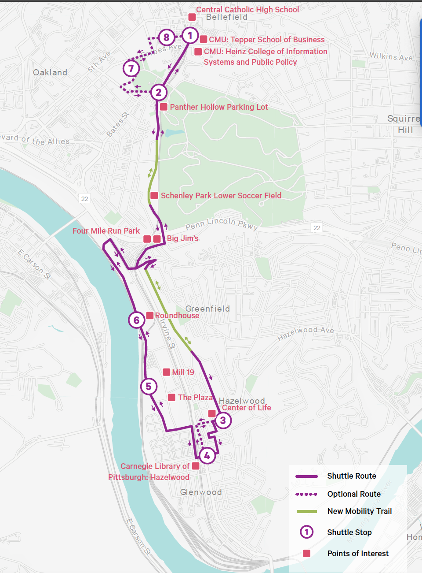
Figure 1: Shuttle Route on Mon-Oakland Connector
The route includes these eight stops:
- S. Craig St. and Filmore St. intersection
- CMU Tepper Quadrangle Loading Dock on S. Neville St.
- Diulius Way path on Boundary St.
- Sylvan Ave and Hazelwood Ave intersection
- Carnegie Library of Pittsburgh: Hazelwood
- Mill19
- Roundhouse
- Schenley Plaza

The estimated travel time for the shuttle averaged 26 minutes to travel from the intersection of Fifth Avenue and S. Craig St. in Oakland to Mill19 in Hazelwood; details on the route are detailed in the rest of this report and in the Appendix. When operating bidirectionally, the shuttle can provide shorter travel times for most trips (34 out of 56 ODs) vs. when operating unidirectionally. Given the positive impact on travel time, we suggest that serious consideration be made to offer a bi-directional shuttle.

For the baseline scenario (with no shuttle) and pre-development in Hazelwood, we estimated about 145 users taking any mode of transportation options for travel between Hazelwood and Oakland. Post-development demand for any mode of transportation is estimated to be about 360 users. With the introduction of the shuttle and based on the post-development demand case using data from Delta Group, we estimated shuttle ridership to increase to 500 users on a weekday and 171 on a weekend day.

From comparing travel time, reliability, cost and safety of the shuttle with that of existing modes of transportation (biking/walking, public bus, driving), we found that the shuttle provides significant time savings at no cost to the user over alternative modes for half of the trips (14 of 28 for each route option) tested between key points of interest in Oakland and Hazelwood/Hazelwood Green. If the shuttle was operated bidirectionally, there would be increased travel time savings for 17 of the 28 trips evaluated for each route option. We therefore are confident that the Mon-Oakland Connector shuttle is a thoroughly researched option to meet the current and projected transportation needs of the community. We look forward to any future collaboration to help move this initiative forward to maximize the equitable economic benefits of the Hazelwood Green development.

Report Detail

Demand Model Methodology and Scenarios
This project’s demand model was calibrated to output the likelihood of a user with a given median annual income would take any one of the modes of transportation considered (public bus, Mon Oakland shuttle, private car, bike/walk) for a trip between key points of interest in Hazelwood and Oakland. Calculations were done for 28 unique trips (called origin destination pairs, or OD pairs) between neighborhoods, and two routes for the shuttle for a total of 56 different trips considered in the model. We modeled the trips from the commuter’s perspective, using metrics that affect the user’s modal choice such as reliability, average travel time, safety, and cost. Outputs from the demand model were combined with various forms of Census data to estimate the modal market share, or the number of affected commuters taking each mode of transportation to make their trip. We also evaluated how demand would change with the introduction of new development in the Hazelwood Green area (or “post-development”, using values generated by the Delta Group’s economic impact study) and across AM peak, PM peak, off peak and weekend time periods.

Post-development travel demand was as a function of adding the estimated number of new jobs generated from the developments of Hazelwood Green to the current number of jobs in relevant block groups. For current jobs, we calculated the total area of nearby and adjacent block groups to each point of interest and using employment density percentages from the US Census. We estimated the demand by creating proportions of jobs between the origin and destination and applied that to the total jobs of the origin block group. The current travel demand in this study is a conservative estimate where the total number of commuters using all modes of transportation remains the same after the introduction of the Connector. However, some commuters who currently drive or take buses may switch to use the Connector thereafter.

Four scenarios were evaluated using the demand model as a basis. In the baseline scenario, we considered all current modes and existing scopes of service. In this baseline scenario, no shuttles or bus service changes are implemented. Driving a personal vehicle is the most popular mode occupying the largest market share in almost all time periods, as the cheapest, most time efficient, safe and reliable mode of transportation. Public transportation occupies the second largest market share of users as a more accessible alternative; however, taking the bus is associated with higher per-trip cost, significant increase in travel time, and decrease in reliability compared to cars.

For the $0-$50,000 income bracket (notably the most vulnerable/sensitive to travel mode changes) before development of Hazelwood Green during the AM Peak period, most commuters take the bus (50%), closely followed by car (48%), and lastly, bike (2%). Specific modal split data is summarized in Table 1 below.

Table 1: Baseline demand case modal split during AM hours for users in the $0-50k income bracket. We consider how many users would use each mode of transportation if there was no shuttle (baseline bus scenario)
Baseline Demand Case - AM Peak Hours
Modal Distribution for $0-50k Income Bracket
# of users | Mode | Percent Market Share
26 | Bus | 50%
25 | Car | 48%
1 | Bike | 2%
52 | TOTAL

In the PM Peak, we observe a similar modal market split with cars and buses closely tied for majority use. These modal market share proportions do not vary significantly from those in the post-development scenario. In Table 2 below, the similarities in modal split between AM Peak and PM Peak demand can be seen when compared to Table 1 above.

Table 2: Baseline demand case modal split during PM hours for users in the $0-50k income bracket. We consider again the modal split in the baseline bus scenario with no shuttle and highlight the similarities between the percent of users within each mode, compared to that of the AM peak hours (Table 1)

Baseline Demand Case - PM Peak Hours
Modal Distribution for $0-50k Income Bracket
# of users | Mode | Percent Market Share
22 | Bus | 44%
25 | Car | 50%
3 | Bike | 6%
50 | TOTAL

The $50-100k income brackets for the same conditions (time and demand case) exhibit a 33% split between cars, bus and bike. When compared to Table 1, you can isolate the effect of income on modal market split (all other conditions kept consistent).

Table 3: Baseline demand case during AM Peak hours for the $50-100k income bracket, the next bracket up from $0-50k, which were shown in Tables 1 and 2

Baseline Demand Case - AM Peak
Modal Distribution for $50-100k Income Bracket
# of users | Mode | Percent Market Share
31 | Bus | 33%
31 | Car | 33%
31 | Bike | 33%
93 | TOTAL

There are 0 users total in the $100k+ income bracket for the baseline demand case and the same modal split (33% for each mode) in the post-development demand case. For each time period in the baseline scenario, we see about 145 users taking any mode of transportation for travel between Hazelwood and Oakland as represented by the OD pairs.

Two other scenarios considered the extension of the 75 bus line across the Hot Metal bridge to provide service into Hazelwood Green, and the operation of the 93 bus line on the weekends. At the time of completing the quantitative analysis for this study, the 93 bus service had not yet implemented a weekend service. Findings in these scenarios are presented in our preliminary report from September 2020 and also in Appendix Part 1.

Mon-Oakland Connector Shuttle
The shuttle scenario introduces the Mon-Oakland Connector shuttle as a supplemental service to Port Authority bus service, offered to citizens free of charge. Compared to the baseline scenario, the shuttle scenario highlights how users may behave to the introduction of the shuttle with all other existing (i.e., baseline scenario) conditions kept the same, such as average bus travel time. The shuttle can also be operated at high, flexible frequency to provide consistent service for commuters. There were two routing options, referred to here as Route Option 1 and 2 modeled for the Mon-Oakland Connector, depending on the preferences of local stakeholders and the maps provided from the Department of Mobility and Infrastructure (DOMI) at the start of this project. The Route Option 1 travels north to Carnegie Mellon University’s Tepper Quad loading dock directly from the Junction Hollow Trail, with the inclusion a small loop around Craig St. to accommodate more ADA users, while Route Option 2 leads the shuttle to travel to Schenley Plaza, and loops around a portion of Oakland before reaching the Tepper Quad. Figure 2 shows the original and updated Option 1 routes, as well as Route Option 2. The southern portion of the maps are identical in their routing to Hazelwood Green.

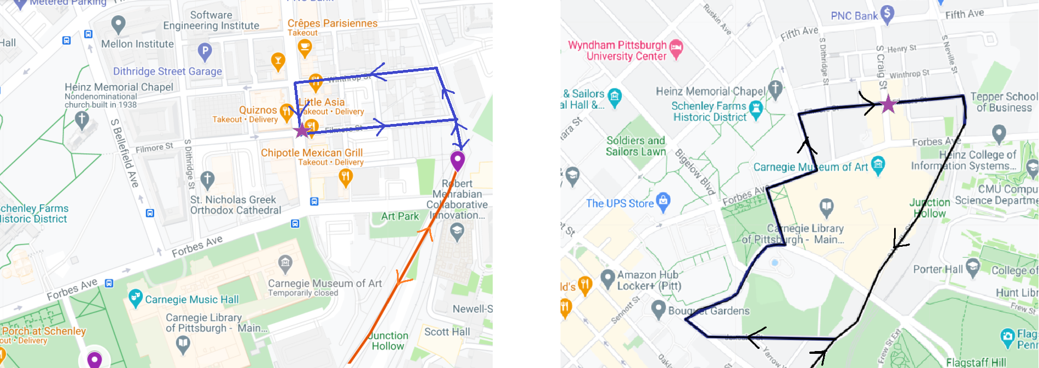
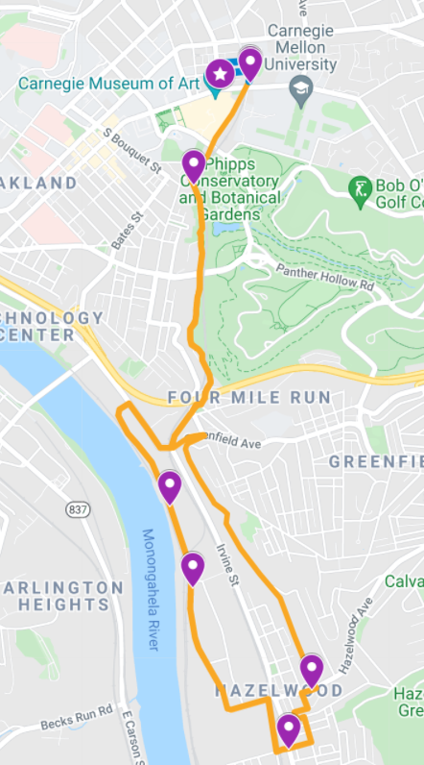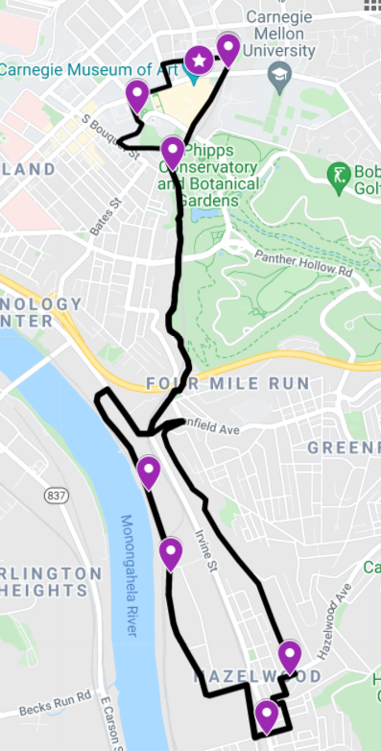
Figure 2: (Left) Route Option 1 is extended (shown in blue) from the current route (in orange) to reach a new stop at Filmore St and Craig St (purple star). (Right) Route Option 2 (in black) with no route change can accommodate new stops on the current design. Purple markers represent stops on the shuttle route. The top two images are closeup maps of the northern portion of the routes, where there are

At the completion of this project we developed a “final map” based on stakeholder feedback and consideration of journey times. The Figure 3 map shows the were two routing options as Route Option 1 and 2, modeled for the Mon-Oakland Connector. The Route Option 1 travels north to Carnegie Mellon University’s Tepper Quad loading dock directly from the Junction Hollow Trail, with the inclusion a small loop around Craig St. to accommodate more ADA users, while Route Option 2 leads the shuttle to travel to Schenley Plaza, and loops around a portion of Oakland before reaching the Tepper Quad. Figure 1 shows Route Option 1 and Route Option 2 (with the dotted line indicating Route 2 as an “optional route” in Oakland); as well as an optional route in Hazelwood that would go on Second Avenue in lieu of neighborhood streets.

Figure 3: Shuttle Route on Mon-Oakland Connector

Compared to bus travel times in the baseline scenario, the shuttle provides significant time savings in 14 out of the 28 ODs for Route Option 1 as well as for Route Option 2 (for a total of 56 ODs evaluated). This means that of these 56 ODs analyzed, we found a total of 28 ODs with time savings, indicating that between the two route options, the shuttle operation presents similar benefits. As shown in red numbers in Table 4, during the weekdays for both route options with the current demand case, the total daily shuttle ridership is about 179 users on a weekday, and 60 users on a weekend day. The maximum time savings between using Route Option 1 or Route Option 2 is under 3 minutes for all ODs considered, which does not have a significant impact on the model market share or shuttle demand volume (number of users taking the shuttle).

Table 4: Summary of daily shuttle ridership from each of the three income brackets. Adding the total number of riders for the respective time period will give the total ridership (total demand is the sum of demand from the $0-50k, $50-100k and $100k+ brackets). Tables below the first table break down shuttle user volume by income group.
Total Daily Shuttle Ridership Comparison (all income brackets)
 | Oakland Loop Route (Route Option 2) |  | Baseline Route (Route Option 1)
 | Baseline Demand | Post-Development Demand | Baseline Demand | Post-Development Demand
AM Peak | 60 | 164 | 60 | 164
PM Peak | 59 | 165 | 59 | 165
Weekend/Off-peak | 60 | 171 | 60 | 171
Total Daily Weekday | 179 | 500 | 179 | 500

Ridership Comparison for $0-50k Income Bracket
 | Oakland Loop Route (Route Option 2) |  | Baseline Route (Route Option 1)
 | Current Demand | Post-Development Demand | Baseline Demand | Post-Development Demand
AM Peak | 36 | 89 | 36 | 89
PM Peak | 35 | 90 | 35 | 90
Weekend/Off-peak | 36 | 93 | 36 | 93
Total Daily Weekday | 107 | 272 | 107 | 272

Ridership Comparison for $50-100k Income Bracket
 | Oakland Loop Route (Route Option 2) |  | Baseline Route (Route Option 1)
 | Current Demand | Post-Development Demand | Baseline Demand | Post-Development Demand
AM Peak | 24 | 72 | 24 | 72
PM Peak | 24 | 72 | 24 | 72
Weekend/Off-peak | 24 | 72 | 24 | 72
Total Daily Weekday | 72 | 216 | 72 | 216
Ridership Comparison for $100k+ Income Bracket
 | Oakland Loop Route (Route Option 2) |  | Baseline Route (Route Option 1)
 | Current Demand | Post-Development Demand | Baseline Demand | Post-Development Demand
AM Peak | 0 | 3 | 0 | 3
PM Peak | 0 | 3 | 0 | 3
Weekend/Off-peak | 0 | 6 | 0 | 6
Total Daily Weekday | 0 | 12 | 0 | 12

In the post-development demand case, the shuttle ridership increases to 500 users on a weekday and 171 on a weekend day. Please note that these numbers only consider commuters, and do not consider users who may use the services for other trips such as buying groceries or for leisure. To calculate the weekend and off-peak demand, we averaged and rounded up users from AM Peak and PM Peak tables for each scenario.

In this study, we assume the introduction of the Mon-Oakland Connector does not induce any additional commuters. The current travel demand in this study is a conservative estimate where the total number of commuters using all modes of transportation remains the same after the introduction of the Connector. However, some commuters who currently drive or take buses may switch to use the Connector thereafter.

The shuttle does not provide advantages for travel from/to the Pittsburgh Technology Center (PTC) since users traveling from/to PTC must walk 19 minutes to Roundhouse to utilize the shuttle service. From comparing the current demand case with and without the Connector shuttle (shuttle scenario and baseline scenario, respectively), we found that many users may transition away from cars and buses to take the shuttle as a result of the potential savings in time and cost. Under the demand case without significant development in Hazelwood (i.e., current demand case), the Connector shuttle (using Route Option 1) during AM peak hours occupies 64% of the market share for users in the $0-50k income bracket (36 out of 56 users), buses occupy 21% (12 out of 56 users) and cars occupy 13% (7 out of 56 users). In the same demand case, income bracket and time period, we observed more users transitioning to shuttle use over car and bus use. This is shown by comparing the modal split between the baseline scenario and shuttle scenarios. Similar travel patterns are observed in the post-development demand case. Interestingly, for the $50-100k income bracket in the baseline scenario, modal market shares are split relatively evenly between bus, bike and car in the baseline scenario (31 users out of 93 for each mode). The proportion is also maintained in the post-development demand case. Compared to the modal split in the shuttle scenario with Route Option 1, user proportions are maintained for cars and bikes, but split between taking the shuttle and bus. For example, in the baseline demand case, both bike and car users occupy 33% (31 out of 93 users), but shuttle occupies 26% (24 out of 93 users) and bus users occupy 8% (7 out of 93 users), with similar patterns seen in the post-development demand case. This shows that users from higher income brackets are less likely to change their preferred mode of transportation for commutes, compared to their counterparts in the $0-50k income bracket. As mentioned before, for tables delineating the number of users as well as the percentages mentioned between time periods, demand cases and project scenarios, please refer to Appendix Part 1.

The study also included an estimation of up to about 1200 g CO2 emissions per trip saved from operating an electric shuttle over making the same trips with conventional private vehicles (i.e. driving). The model is based off the fuel economy (miles/gallon), which is converted into fuel consumption. A CO2 conversion factor of 8887 grams/mile was applied to find the CO2 emission rates for appropriate vehicle speeds. A table summarizing findings from this emissions study are also found in the Appendix. When operating bidirectionally, the shuttle can provide shorter travel times for 34 out of 56 ODs than when those trips are made by public bus, compared to just 28 out of 56 ODs when operating unidirectionally. If operational difficulties with navigating the shuttle through the narrowest parts of the route are resolved, a bi-directional shuttle can be more seriously considered. Considerations should be made on the challenges of the current route and the placement of stops to best serve communities of interest.

In addition to the mobility study of the Mon-Oakland Connector project, our research also included an evaluation of 40 different mobility shuttle operations from around the world to better understand relevant, free public transit services (shuttles) offered. The case studies range from shuttle services offered on corporate and university campuses to neighborhoods and cities. We divided service types in four categories: transport network, transport operator, mobility solutions and technology platform. Our evaluation focused on five examples picked out of a list of 40 that were studied. From the case studies, we created a “hybrid shuttle model” that mixed and matched different aspects of the case studies. The hybrid shuttle model was presented in three buckets: transit plan, vehicle requirements and tracking system. The intent of the hybrid shuttle model was to address the numerous issues and questions raised with DOMI- much of which was based on input from the community in public meetings. We used this information to help recommend options viable for the Mon Oakland Connector service and inform the work of U3 Advisors and Innovate Mobility.

Split Route Option and BRT Considerations
Incorporating feedback from more stakeholders, we also modified the route to support ADA compliance and boost user visibility, an additional shuttle stop can be placed at Craig St and Filmore St. Assuming that the additional stop on Craig St. is accepted, we also explored how shuttle travel time would be improved if two shuttle routes were implemented simultaneously: one shuttle traveling to the Schenley Plaza, and one shuttle traveling to the new stop on Craig St and Filmore St. This “split route” scenario would reduce travel time by up to 7 minutes, as well as reduce traffic on busy roads and provide more localized service to nearby major transit connections. More details on the “split route” scenario are shown below with Figure 2. We also modeled the BRT through the SR 885/Second Ave corridor with an express bus service (referred to here as the “Hazelwood BRT”), as proposed in the 2019 SPC Second Avenue Multimodal Corridor (referred to here as the “SPC report”) for general travel from Oakland to Hazelwood Green. We found that implementing the bus service on the BRT and connecting it with the Oakland-Downtown BRT can provide notably faster transit over current Port Authority of Allegheny County (PAAC) bus services for travel between the neighborhoods of interest. However, there are several challenges in implementing the BRT (as a long-term solution) and the BRT would be a complement to the Mon Oakland Connector, which is anticipated to be implemented before the completion of the BRT. Further findings from this evaluation can be found in Appendix, Part 3.

The Metro21 team investigated the ADA-compliance and utility of the key stop at the Tepper Loading Dock on South Neville Street. This stop would provide connections to the Oakland-Downtown BRT as well as service for local students, employees and residents. We consulted CMU’s Campus Design and Facility Development office and confirmed that the Tepper Loading Dock is not easily accessible. Another stop should be added locally to provide equitable service in the area; we suggest adding a second, more ADA-accessible stop by Craig St. and Filmore St. in Oakland, as shown as a purple star Figure 1 earlier in the report. Adding the stop would not add to travel time on Route Option 2, or 1-2 minutes on Route Option 1. 1 minute of shuttle stopping time to affected trips and save at least 4 minutes walking time from the point of interest Fifth Ave. and Craig St., used for the team’s mobility study. These estimations include effects from possible traffic delays by assuming that each signalized intersection adds 20 seconds to total travel time.

The “split route” scenario explores the effects on travel time of having two shuttle routes that separate at the intersection of Joncaire St. and Boundary St. to service unique areas simultaneously, as shown in Figure 2. The pink loop services the Craig St. area close to the planned Squirrel Hill BRT route, CMU and local businesses. The blue loop services the central Oakland area, local businesses and the University of Pittsburgh. The separation of the orange route into the two divergent paths prevents the shuttle from traveling on high congestion corridors like Forbes Ave. and Fifth Ave. (compared to the original Route Option 2 configuration), which improves shuttle travel time, user experience and safety. Compared to Route Option 2, the split routes would divert shuttle traffic away from Forbes Ave. back onto less busy streets such as S. Bouquet St. and Joncaire St., saving up to 4 minutes for trips between Oakland and Hazelwood Green. Please see the Appendix Part 2 for the full travel timetable.

The split route would also naturally include the new ADA-compliant stop at Craig St. and Filmore St. If the new stop at Craig St. and Filmore St. is implemented with a split route (this does not change the routes at all), there is an additional time saving of at least four minutes from walking between the point of interest at Fifth Ave. and Craig St. to the shuttle stop. The combination of the split route and the new stop can save up to seven minutes for affected origin destination pairs.
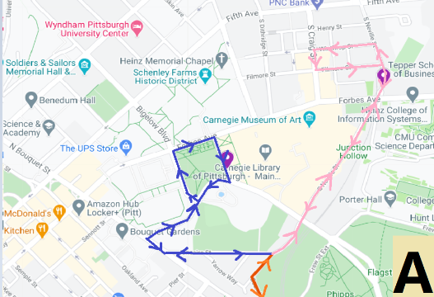
Figure 2: Map showing how the main route (orange) splits into the two routes (pink and blue). The pink loop services Craig St., and the blue loop services Oakland/Schenley Plaza.

In the latest iteration of shuttle route design, stakeholders have taken more feedback from public meetings for a new route with an addition of a stop at the intersection of Tecumseh St. and Second Ave., in front of the Carnegie Library of Pittsburgh, Hazelwood branch. The Metro21 team also developed a new demand model for a route identical to Hazelwood Green website, shown in Figure 3. The model featured in this latest iteration considers the Option 1 route (labeled “Shuttle Route” in Figure 3) and the Option 2 route (labeled as an extension of Option 1 as “Optional Route”), and an additional at the intersection of Filmore St. and S. Craig St. for a total of 8 stops. In summary, the changes between the previous route iteration and the latest iteration are as follows:
- Updating Four Mile Run section of the route to reflect the website route
- Updating the Hazelwood residential section (by Marsden St) of the route to reflect the website route
- Ensuring the stop at the Hazelwood Library (Tecumseh St.) is reflected in the analysis
- Including trip times for scenarios where the shuttle is bi-directional as well as uni-directional
- Move the Schenley Plaza stop in Oakland from the Schenley Drive Extension to Schenley Drive (opposite sides of Schenley Plaza)
- Calculations now propagate the effects of adding the Filmore/S. Craig St. stop throughout model

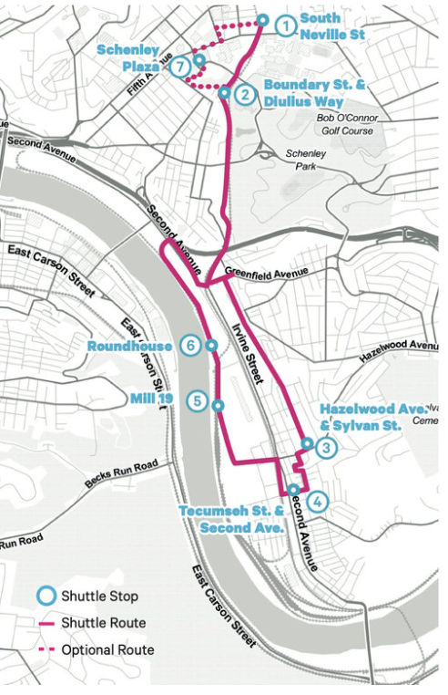
Figure 3: Latest iteration of the Mon-Oakland shuttle route is identical to this one shown, from the Hazelwood Green website (https://www.hazelwoodgreen.com/hazelwood-oakland-shuttle).

With the introduction of the Carnegie Library stop, the walking time for origin-destination pairs involving this point of interest decreases to zero minutes, saving affected trips five minutes of total travel time. The largest time savings from adopting this route is nine minutes for the OD trip between Carnegie Library to Fifth Ave/Atwood St. The route update can also add up to five minutes on some OD pairs. 18 out of 28 OD pairs had at least some time savings from implementing the latest route with stop additions.

By implementing a bidirectional route (see Appendix C-4), users can save up to 29 minutes for 28 out of 56 OD pairs (not counting 4 ODs that do not have shuttles available or the 2 ODs from Mill19 to Roundhouse that are walking distance). As shown in Table 5, shuttle ridership increases significantly for the $0-50k income bracket, increasing by 7.4% or 20 users from 272 to 292 users per weekday with the post-development demand case, between unidirectional to bidirectional travel, respectively. The increase is observed between both route options 1 and 2. There are no changes in shuttle ridership for other income brackets between unidirectional and bidirectional routes.

Table 5: Summary of unidirectional (left) versus bidirectional (right) shuttle route ridership volume on a weekday, for both Route Option 1 and 2, across the most vulnerable income bracket of $0-50k.
Ridership Comparison for $0-50k Income Bracket- Unidirectional |  |  |  |  | Ridership Comparison for $0-50k Income Bracket- Bidirectional
 | Oakland Loop (Route Option 2) |  | Baseline Route (Route Option 1) |  | Oakland Loop (Route Option 2) |  | Baseline Route (Route Option 1)
 | Baseline Demand | Post-Development Demand | Baseline Demand | Post-Development Demand | Baseline Demand | Post-Development Demand | Baseline Demand | Post-Development Demand
AM Peak | 36 | 89 | 36 | 89 | 37 | 100 | 37 | 100
PM Peak | 35 | 90 | 35 | 90 | 36 | 99 | 36 | 99
Weekend/Offpeak | 36 | 93 | 36 | 93 | 36 | 93 | 36 | 93
Total Daily Weekday | 107 | 272 | 107 | 272 | 109 | 292 | 109 | 292

This means that the average number of overall shuttle riders on a given weekday would increase by 7.4% if shuttle operation becomes bidirectional versus unidirectional. Users shift from using bus and cars to shuttle due to the time savings made available by a bidirectional route (see Appendix C-8 for modal market shares with a bidirectional shuttle route), which seem to most significantly impact the $0-50k income bracket. This observation also supports that this income bracket is the most vulnerable to changes in cost to commute and could benefit the most from free (to users) operation of the proposed shuttle.

Conclusion
With planned development in Hazelwood in the Mill19 and Roundhouse areas, traffic volume is expected to increase along with the social and economic growth. To meet the growing need for safe, accessible, and reliable transportation between Hazelwood Green and Oakland, alternative modes of transportation and improvements on existing modes are being evaluated based on the projected impact they can bring. This report summarizes our findings from using data-driven modeling and organized public-private collaboration to objectively estimate how much faster, safer, more reliable and cost effective some of the considered transit options could be, before and after substantial development in Hazelwood Green. The Mon-Oakland Connector following a hybrid shuttle model would present considerable time savings for commuters traveling between Oakland and the Hazelwood Green development site; for 28 out of 56 OD pairs evaluated, the shuttle could save up to 29 minutes in average travel time, while being free of cost and without bus transfers. Both Route Option 1 and Route Option 2 within the shuttle scenario (users can take a bus, bike or drive) provide comparable benefits over the baseline scenario (which reflect the current state, where there is no shuttle service). We observed that the income bracket that had the most change in their preferred mode of commute transportation was the $0-50k bracket, with the introduction of the Mon-Oakland shuttle. 26 out of 52 users took the bus during AM Peak hours in the baseline scenario, which dropped to 12 out of 52 users while the shuttle would have 36 users. The shuttle’s operational and route details are consistently reviewed by stakeholders to ensure that the shuttle meets community needs and synergizes with concurrent projects. As a continued effort to improve and update the shuttle plan, we assessed the benefits of an accessible, new stop on Craig Street, and of running a ‘split route’ shuttle that supports distinct service areas by the University of Pittsburgh campus and CMU campus. We also observed in the model that operating the shuttle bidirectionally, rather than unidirectionally, can enable users to travel faster for 34 out of 56 ODs compared to the same trips made by public bus. In acknowledgement of other transportation solutions besides the shuttle, we also evaluated the potential impacts of expanding other existing bus services and implementing a Hazelwood BRT in accordance with plans from the SPC SR 885 Corridor Study from 2019.

With economic development in Hazelwood Green, we anticipate higher traffic, increased commuter demand, and the immense potential to uplift local communities. The importance of having reliable, affordable and accessible transportation drives the quantitative and qualitative analyses that are summarized in this report. From comparing travel time, reliability, cost and safety of the shuttle with that of existing modes of transportation (biking/walking, public bus, driving), we found that the shuttle provides significant time savings at no cost to the user over alternative modes for about half of the trips (14 of 28 for each route option) tested between key points of interest in Oakland and Hazelwood Green. If the shuttle was operated bidirectionally, there would be similar travel time savings for 17 of the 28 trips evaluated for each route option.

Appendix link

