Seepage – Student Pages
Complete the following. Answers to questions 2 and 4-9 must be in sentence form.

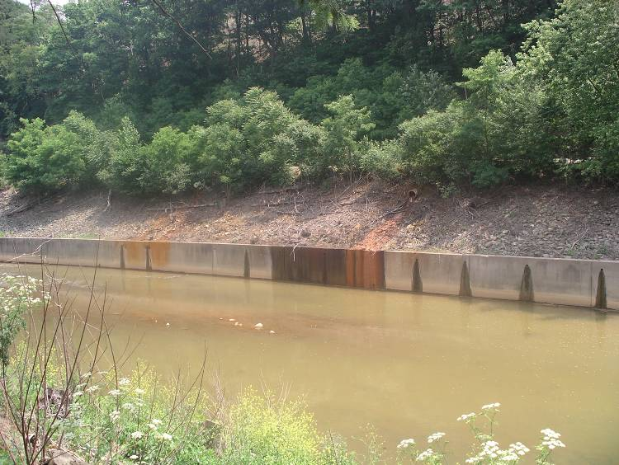

Seepage is the flow of a liquid through small openings, such as water moving through small spaces in soil. The liquid may carry contaminants with it. The contaminated liquid may seep or flow through a permeable layer of rock or soil, but when the contaminated liquid hits an impermeable layer it does not seep through it.

1. Study the Geologic Sample and label the following diagram. Label the layers of soil, gravel, sand, and clay (use the dotted lines). There may be more than one of each.

Geologic Diagram of Sample A

1
---------------------------

2
---------------------------

3
----------------------------

4
----------------------------

5
-----------------------------

Pour the sample of Methyl-Ethyl Death (Sample B) into Geologic Sample A. Let it sit for at least 10 minutes. What do you think will happen to the liquid? NOTE: This liquid is NOT harmful but represents a hazardous chemical that might be found at a brownfield.
- Draw (using colored pencils) the movement of Methyl-Ethyl Death through the Geologic Sample A.

1
---------------------------

2
---------------------------

3
----------------------------

4
----------------------------

5
-----------------------------

3. At what layer did the Methyl-Ethyl Death stop moving through the Geologic Sample
A?

4. Why do you think the Methyl-Ethyl Death stopped moving down?

5. How many layers did the Methyl-Ethyl Death go through?

6. Which layers of Geologic Sample A are permeable? How do you know?

7. Which layers of Geologic Sample A are impermeable? How do you know?

9. Methyl-Ethyl-Death represents a toxic (harmful) substance that was spilled in a neighborhood. If a chemical actually spilled, or was dumped, on the soil would the contaminants stay at the top layer? Explain why or why not.

10. What might happen if the contaminants seeped through the soil to underground water that was used for a drinking well?

11. How does this relate to the seepage of water through a brownfield site?

Reviewer’s Signature: Rubric Score: 5, 4, 3, 2, 1

