Car Wash – Key

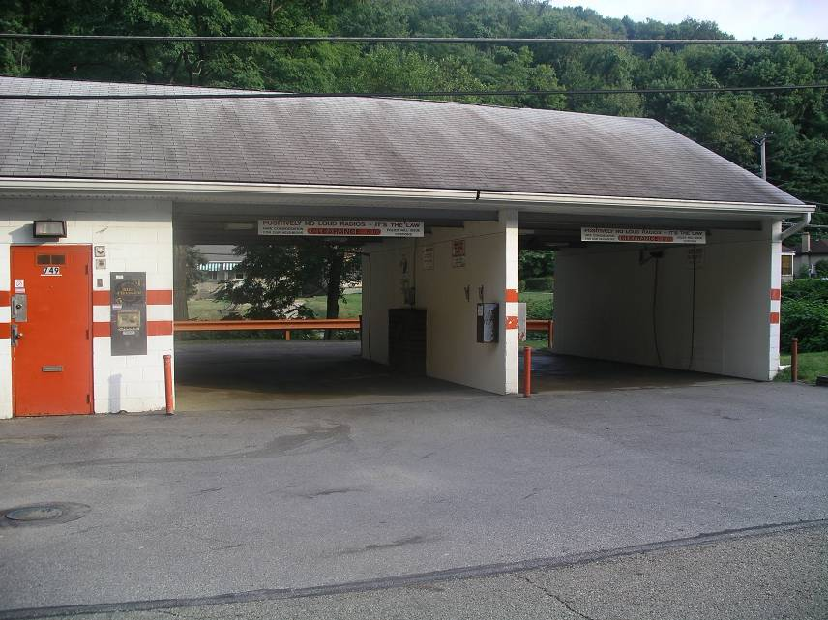

You want to build a carwash on an empty piece of land that is considered a brownfield. The piece of land is located in Anytown, Pennsylvania. The land looks like it might have once had a gas station on it. When you check on the price of the land you learn that you can buy it for only $5,000.00. A piece of land in McKees Rocks this large would normally cost about $100,000.00. Somebody tells you that there might be money available to help you with the cleanup and development of the land, and suggests that you look into this.
(Answer the following in sentence form, using additional paper if necessary.)

1. What research would you have to do before you decide whether to build a car wash on this property? Before deciding whether to purchase the land, it would be good to find out about its prior uses, by checking previous deeds and business that have been there. It would also be necessary to learn about contaminants that are typically found on gas station sites and possible remediation techniques that would make the land safe for new development. The Environmental Protection Agency and the Pennsylvania Department of Environmental Protection could provide information about tests to determine the extent of the contamination (if any) on the site, and could provide information about funds that are available to help with the remediation and redevelopment costs. Since redevelopment of brownfields allows us to make use of existing infrastructure, it would be good to compare how much work would be necessary to develop the same car wash business at another site; the fact that a business once operated in the same place would mean that utilities and other support for the business are probably in place.

2. What are some methods of cleaning (remediating) the property that might be used?
People can move the contaminated soil (but then there is a question of where it can be taken), encapsulate it on the property, or clean it using a method that is determined to be effective for the type of contaminant that is found. Innovative remediation techniques used at distressed brownfields properties in recent years include bioremediation, which uses microorganisms to remove or break down contaminants in soil or groundwater, and in situ oxidation, which uses oxidizing chemicals to degrade contaminants. These strategies are often used in conjunction with one another or with other techniques such as soil vapor extraction, which extracts some types of contaminants in the form of a vapor that is captured for treatment. Some brownfields with heavy metal contamination have even been cleaned up through an innovative approach called phytoremediation, in which certain plants that are known to extract metals from the soil into their tissues are planted on the brownfield site. As they grow, the plants absorb the metals, so all one has to do to remove the metals is harvest the plants and dispose of them as hazardous waste once they reach maturity. This leaves the soil cleaner than before. (http://en.wikipedia.org/wiki/Brownfield_land)

3. What would building this car wash do to improve the community?
Building a car wash on a brownfield would replace a blighted property with a useful service to the community. It would make the land safer for people and animals, and prevent further contamination of groundwater. Developing the brownfield would remove eyesores like weeds and piles of trash, and discourage further dumping. Since people are reluctant to build on property that is adjacent to a brownfield, cleaning up a brownfield tends to increase the value of surrounding properties. The new business would also provide services for the community and create jobs for people who live there. Finally, the revenue the local government would get from the taxes paid by the business could be spent on improving the community.

4. What would you name your new car wash business?
Any answer would be acceptable here; creativity is encouraged.

