Brownfield Identification

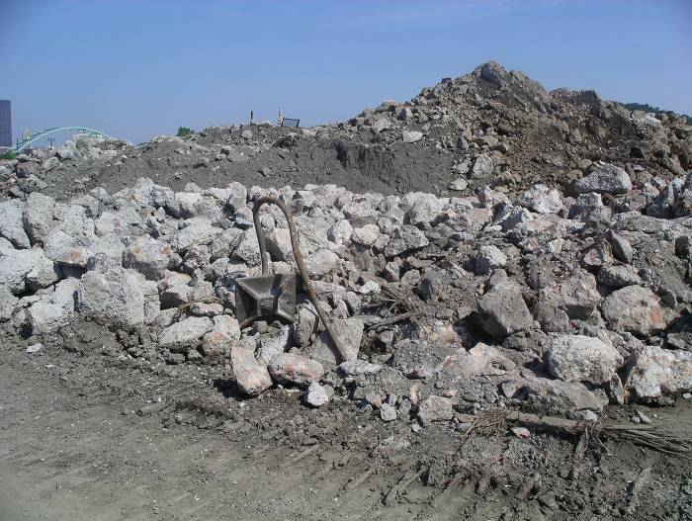

Imagine that you want to develop a piece of land for a new business. Explain which land from the brownfield card activity you would want to develop. Your response must explain why you would prefer to purchase and build on that piece of land. Then explain which piece of land you would not want to develop. Make sure that you use information about the contaminants found on the property, and that your answers are in sentence form.

I would prefer to develop a business on (card number) because

I would NOT want to develop a business on (card number) because

