Brownfields Identification Lab: Student Page
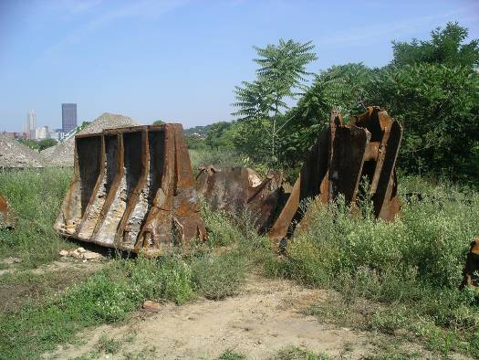

Stop at each container in the classroom, unearth the contaminants in the soil, and list them along with the container number on the chart. Use the Guide to Brownfield Contaminants to determine the prior use of the land, and state whether it is a brownfield.

Container Number | List the contaminants found. | What might have been on the land? | Is this a brownfield?

