Camille Bove - Argentina

I was originally looking for opportunities in Latin America to study music over the summer and did not find any. The seasons in South America are the reverse of those in North America, so programs catering to my summer are not likely to appear, especially since not many people abroad are looking to study classical music in Latin America. With that, I set my sights on studying in a city, Buenos Aires, that had a lot of classical music even if I was not necessarily enrolled in a program for it. I signed up for a class in Latin American literature and opted to find my own musical opportunities beyond the program.

That being said, I did get a lot of cultural background with the class. It was surprisingly rigorous with our professor only speaking in Spanish, us having to analyze literature and having to write weekly reports on said literature in Spanish. Poetry in particular is difficult for language students as it frequently draws upon cultural themes and often plays with grammar. It took time for us to figure out which words were spelled incorrectly or made up. We read through various stories while learning about the cultural background that informed each story. Martín Fierro was an epic poem integral to the formation of Argentine national identity during a period of mass European immigration. It was the first story we read, setting us up to read all sorts of stories with underlying criticisms of Martín Fierro, marking eras where Argentine identity shifted.

Beyond my class, I was also successful in engaging in a lot of musical activities. I visited Teatro Colón, Centro Cultural Kirchner, and Teatro Argentino de La Plata. I took lessons with a former student of my current teacher, played for a community orchestra, and even got to partake in an audition for La Orquesta Estable del Teatro Argentino. I did not win the position, but the process of preparing the audition material and taking part in a professional audition for the first time in my life was amazing. Beyond classical music, I also got to play a little bit of tango and attended a Latin American percussion class in Barrio Mugica taught by a friend I made there.

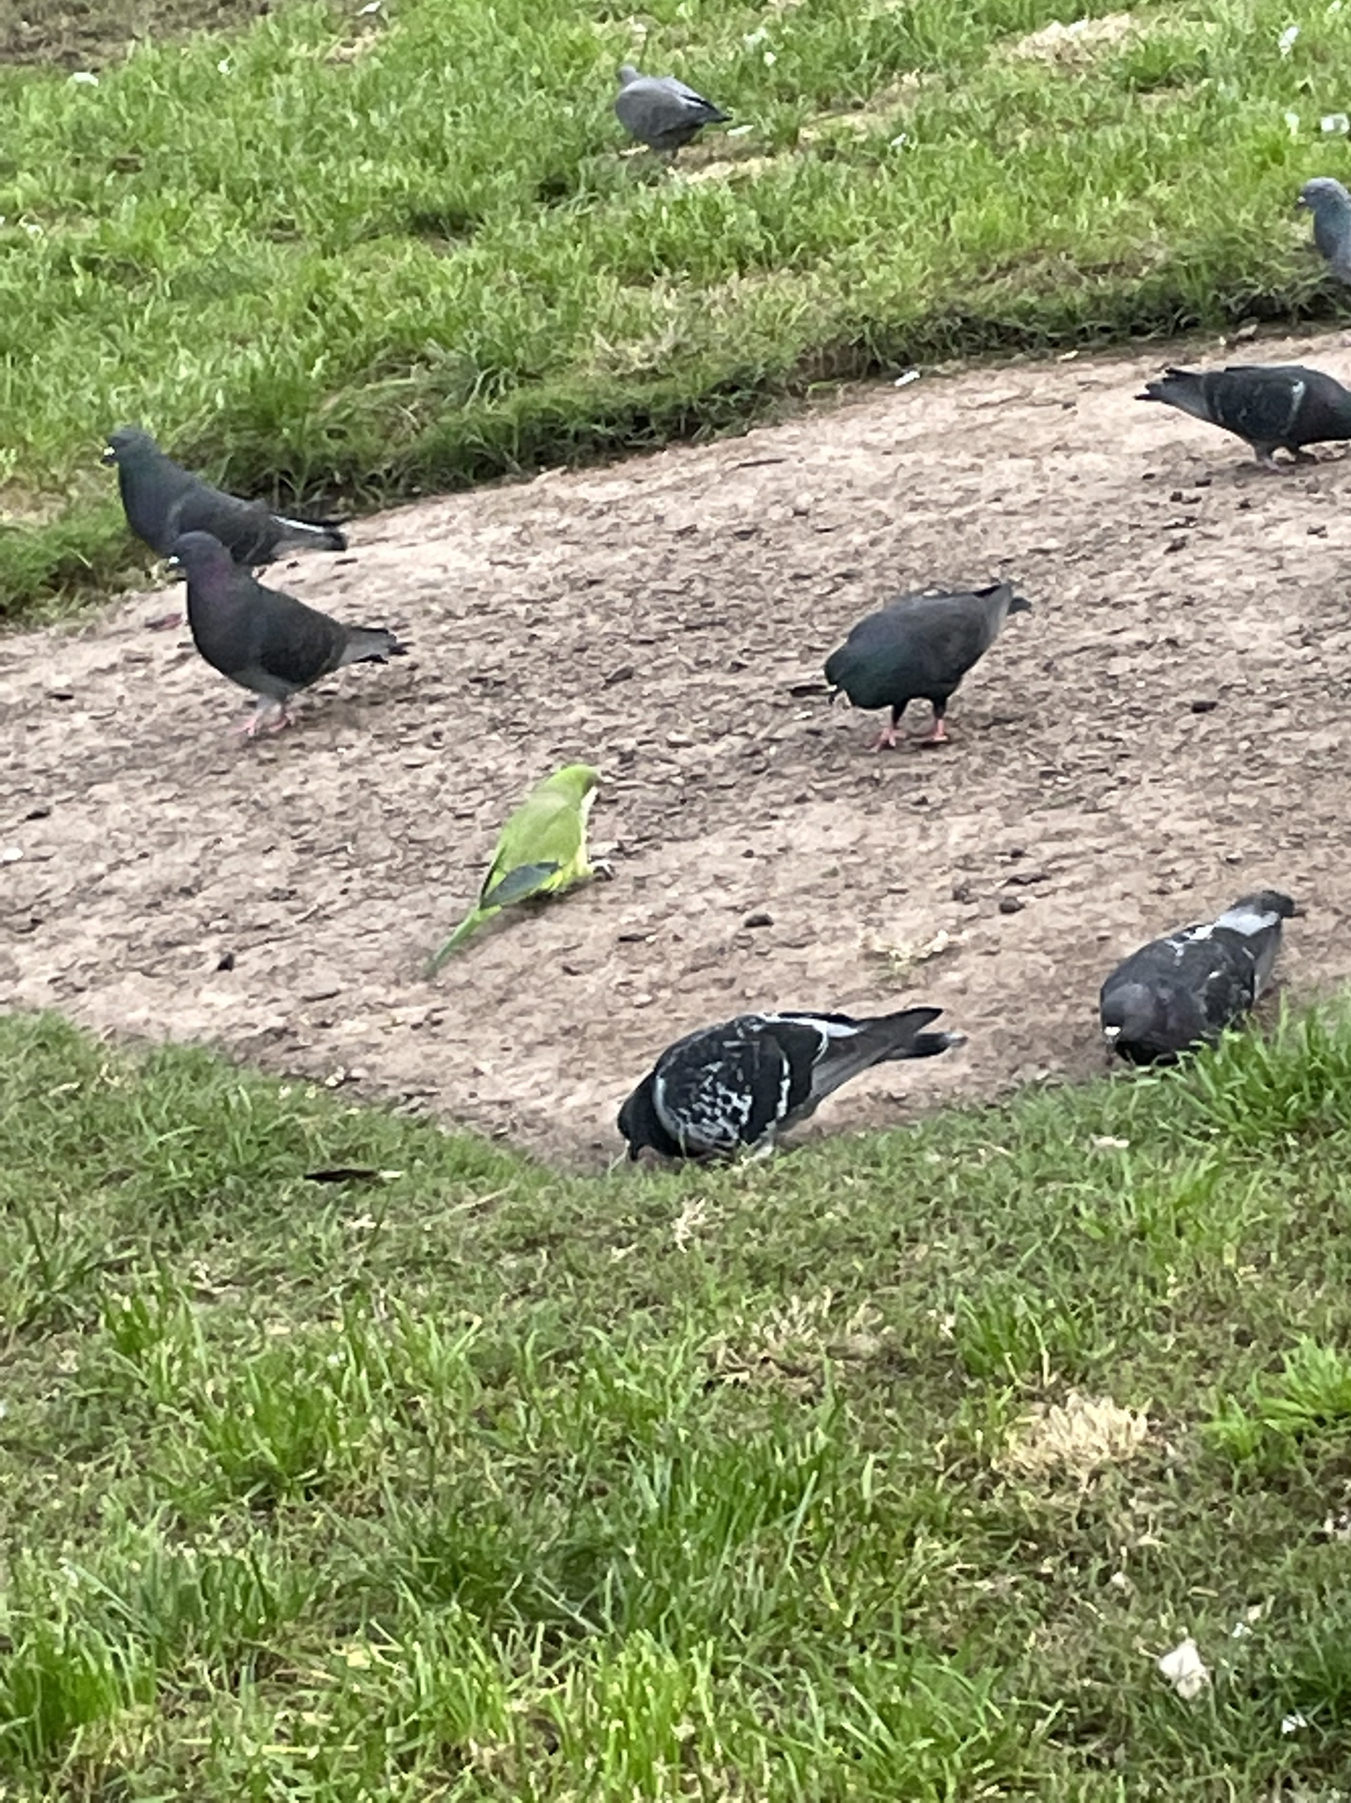
A monk parakeet surrounded by pigeons. My favorite bird in Buenos Aires.
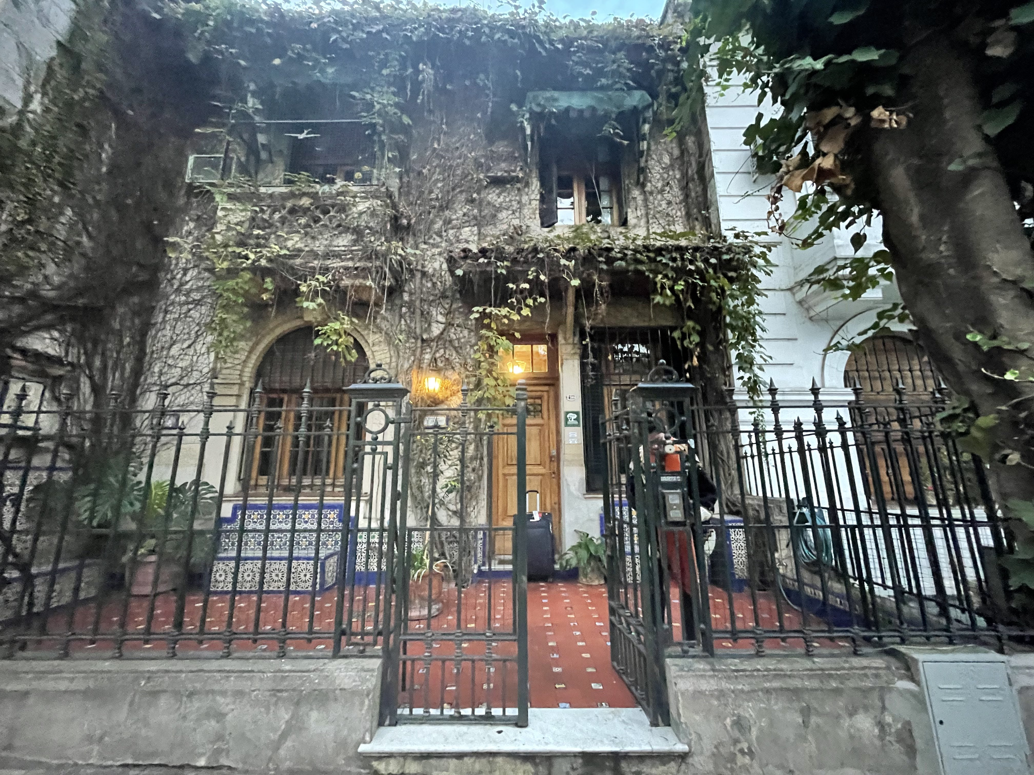
The house I stayed at was in a “Barrio Inglés,” referring to a type of community in Buenos Aires with a concentration of English architecture. This is in a neighborhood known as Caballito, which contains the most famous Barrio Inglés. The commute to my classes in San Nicolás was a little inconvenient since I was rather far compared to my classmates. I quickly learned that the Subte (Buenos Aires’ rapid transit system) was faster than the collectivo (bus) for these longer trips.
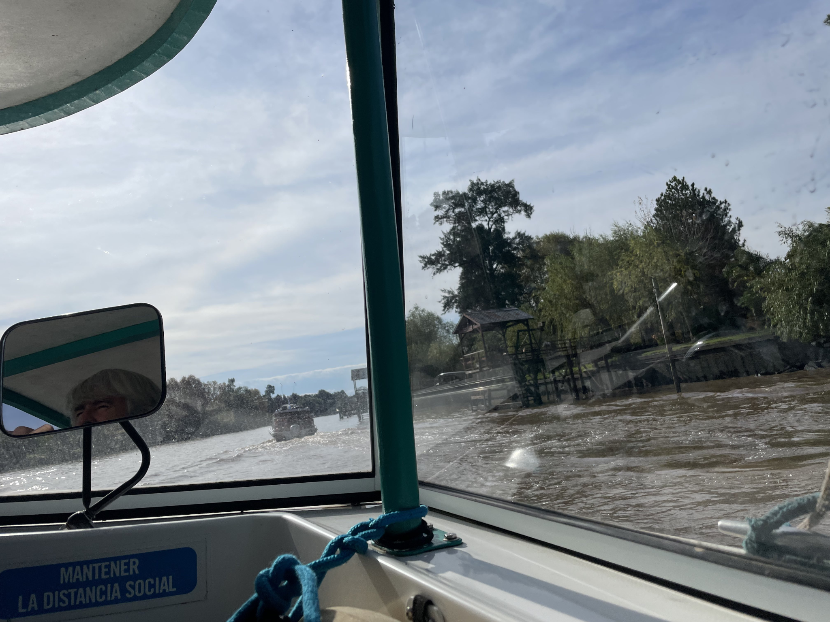
Tigre, a community around a river. It is a popular vacation spot for Argentines, though it has its own community and history beyond that.

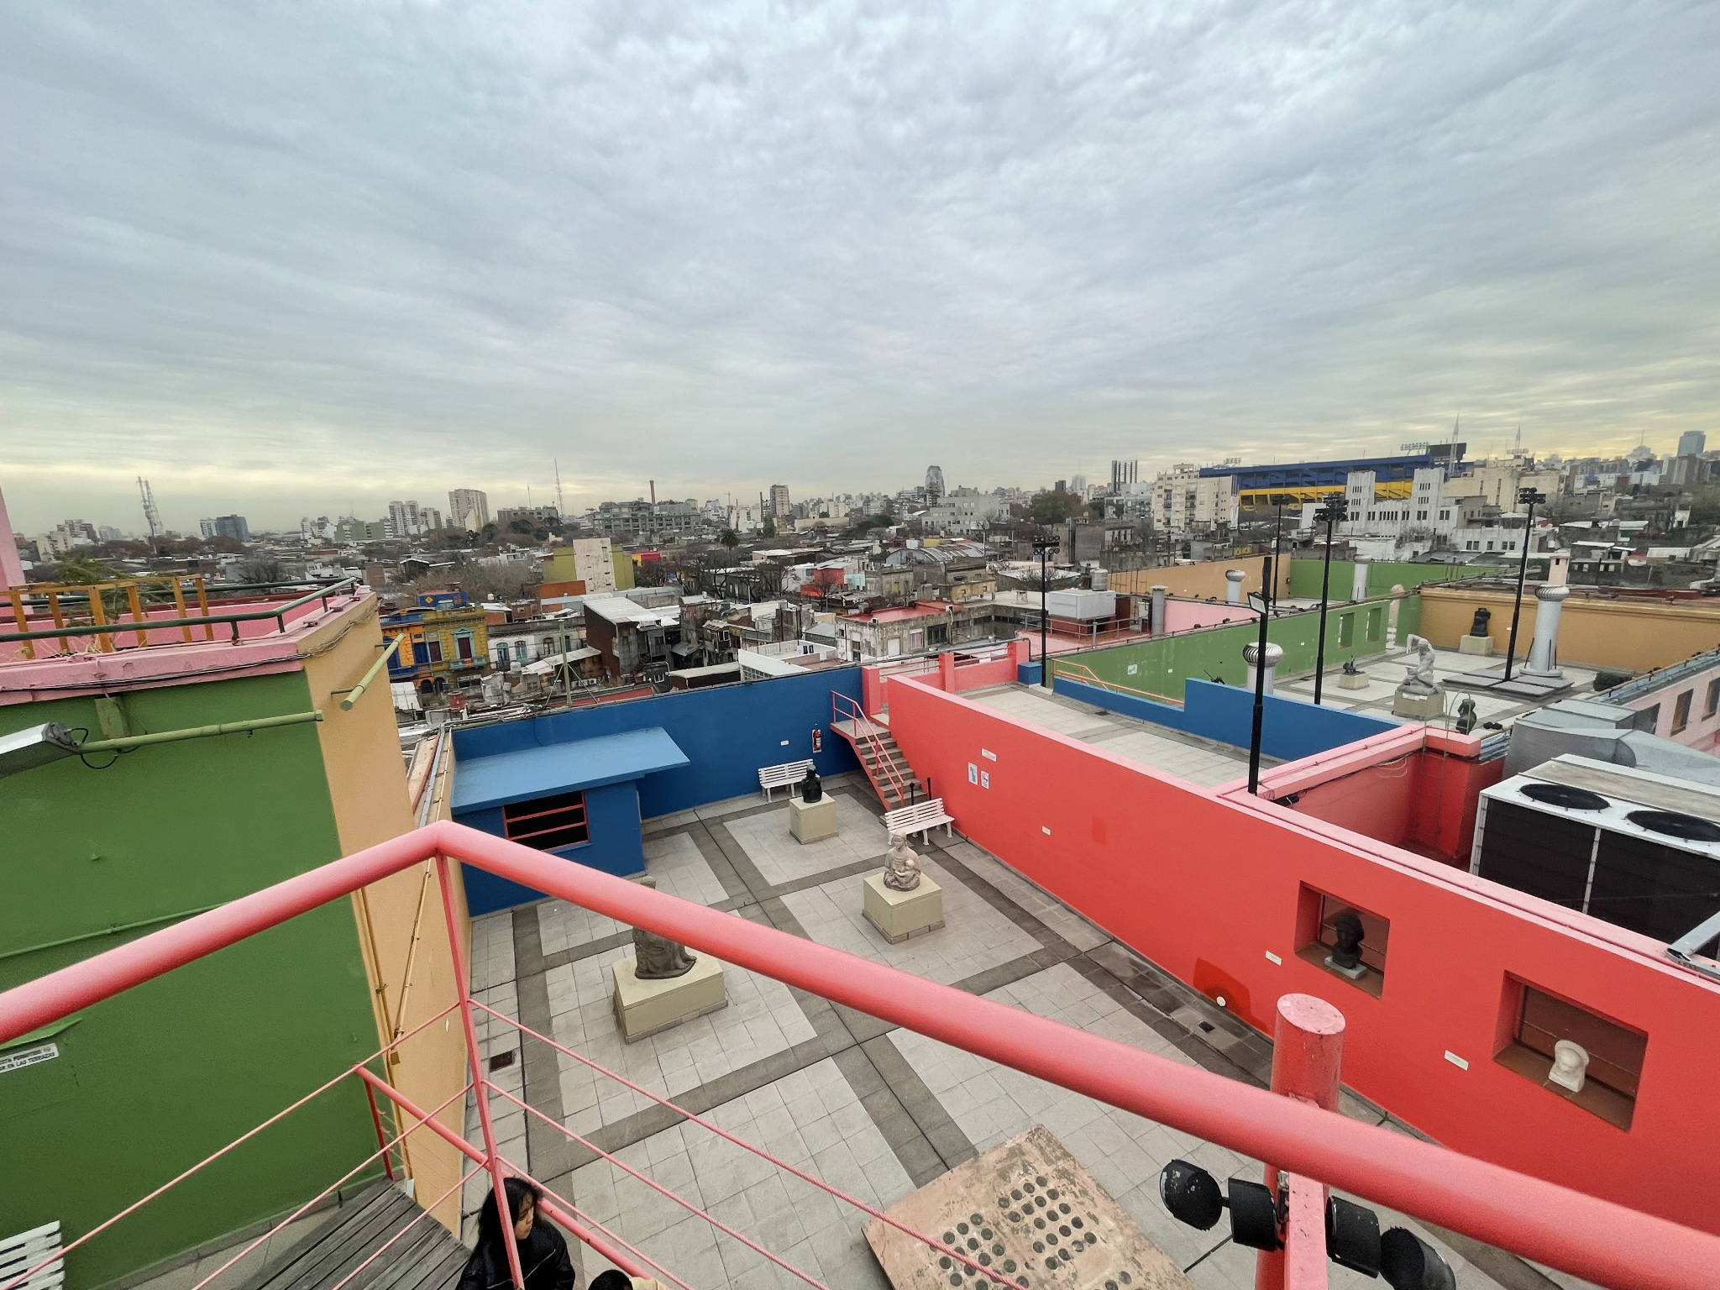
View of La Boca from the top of a building. La Boca is known for being the home of a world-renowned youth football team as well as El Caminito, a colorful alley full of art and music. It is a poorer neighborhood and tourists are told to be careful about straying beyond the tourist locations. Its identity as a poor neighborhood is integral to its identity and that is not in the slightest bit ignored in all of the art the surrounds it.

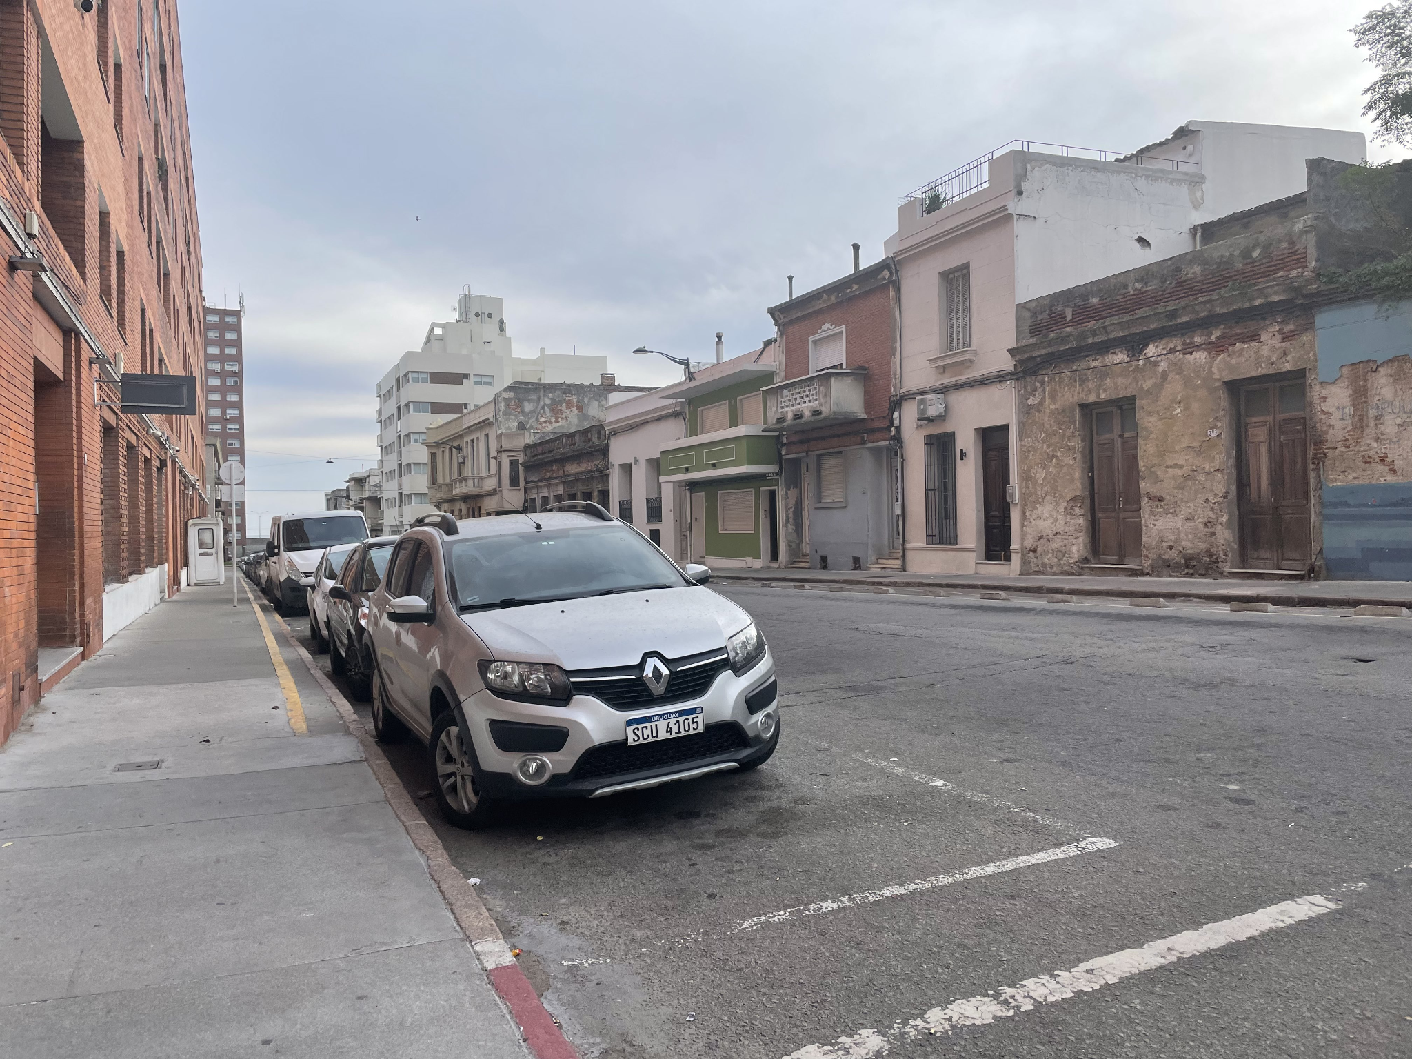
Montevideo, Uruguay. I did not spend much time in Uruguay, but the cultural and historical similarities to Argentina were interesting to note. The two countries squabble a bit over what traditions came from which country.

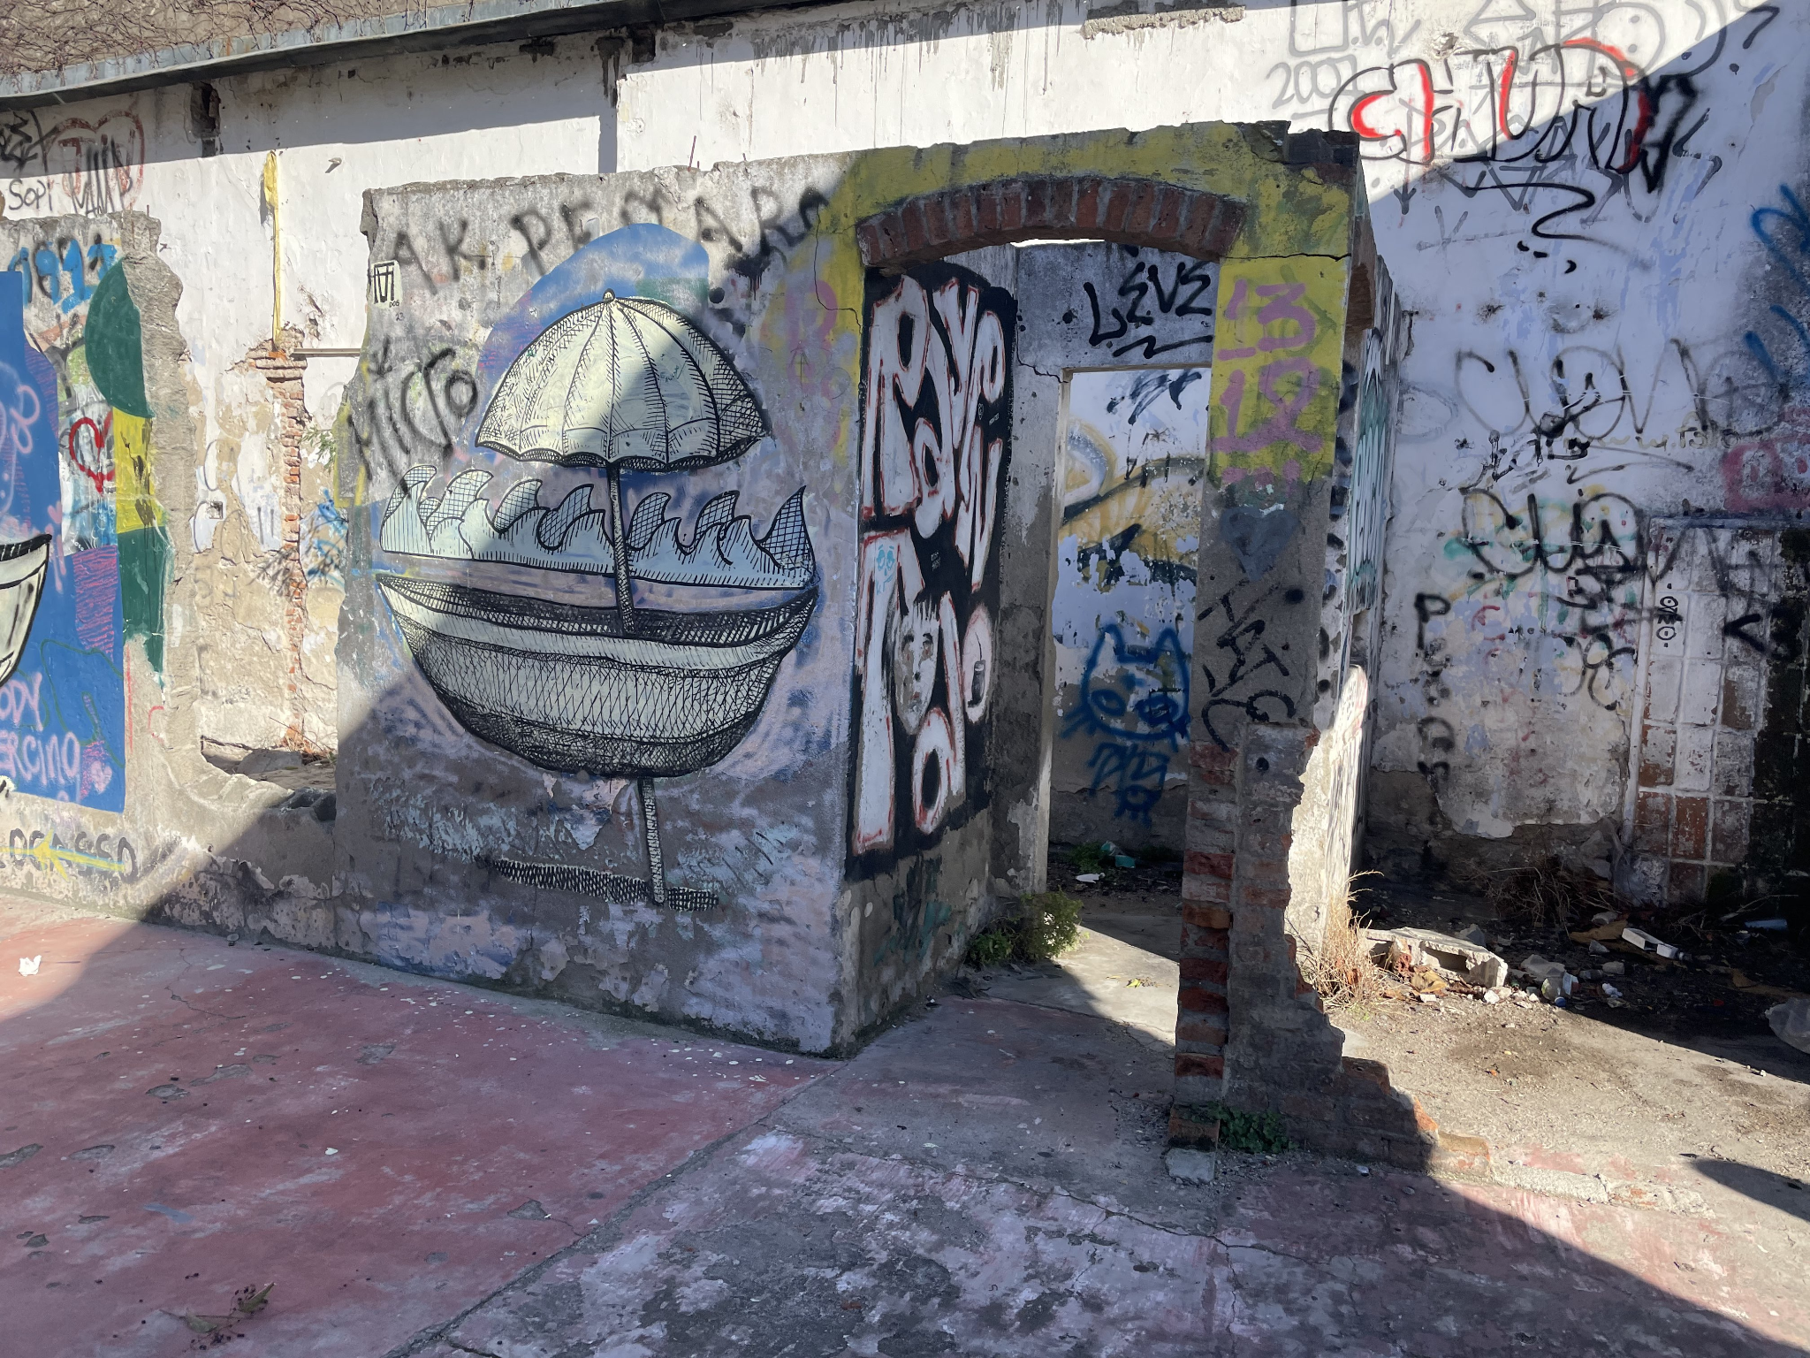

Graffiti in Colonia del Sacramento, Uruguay. I found this city to be absolutely gorgeous. I took a boat from Buenos Aires to get here and then took a bus from here to get to Montevideo.

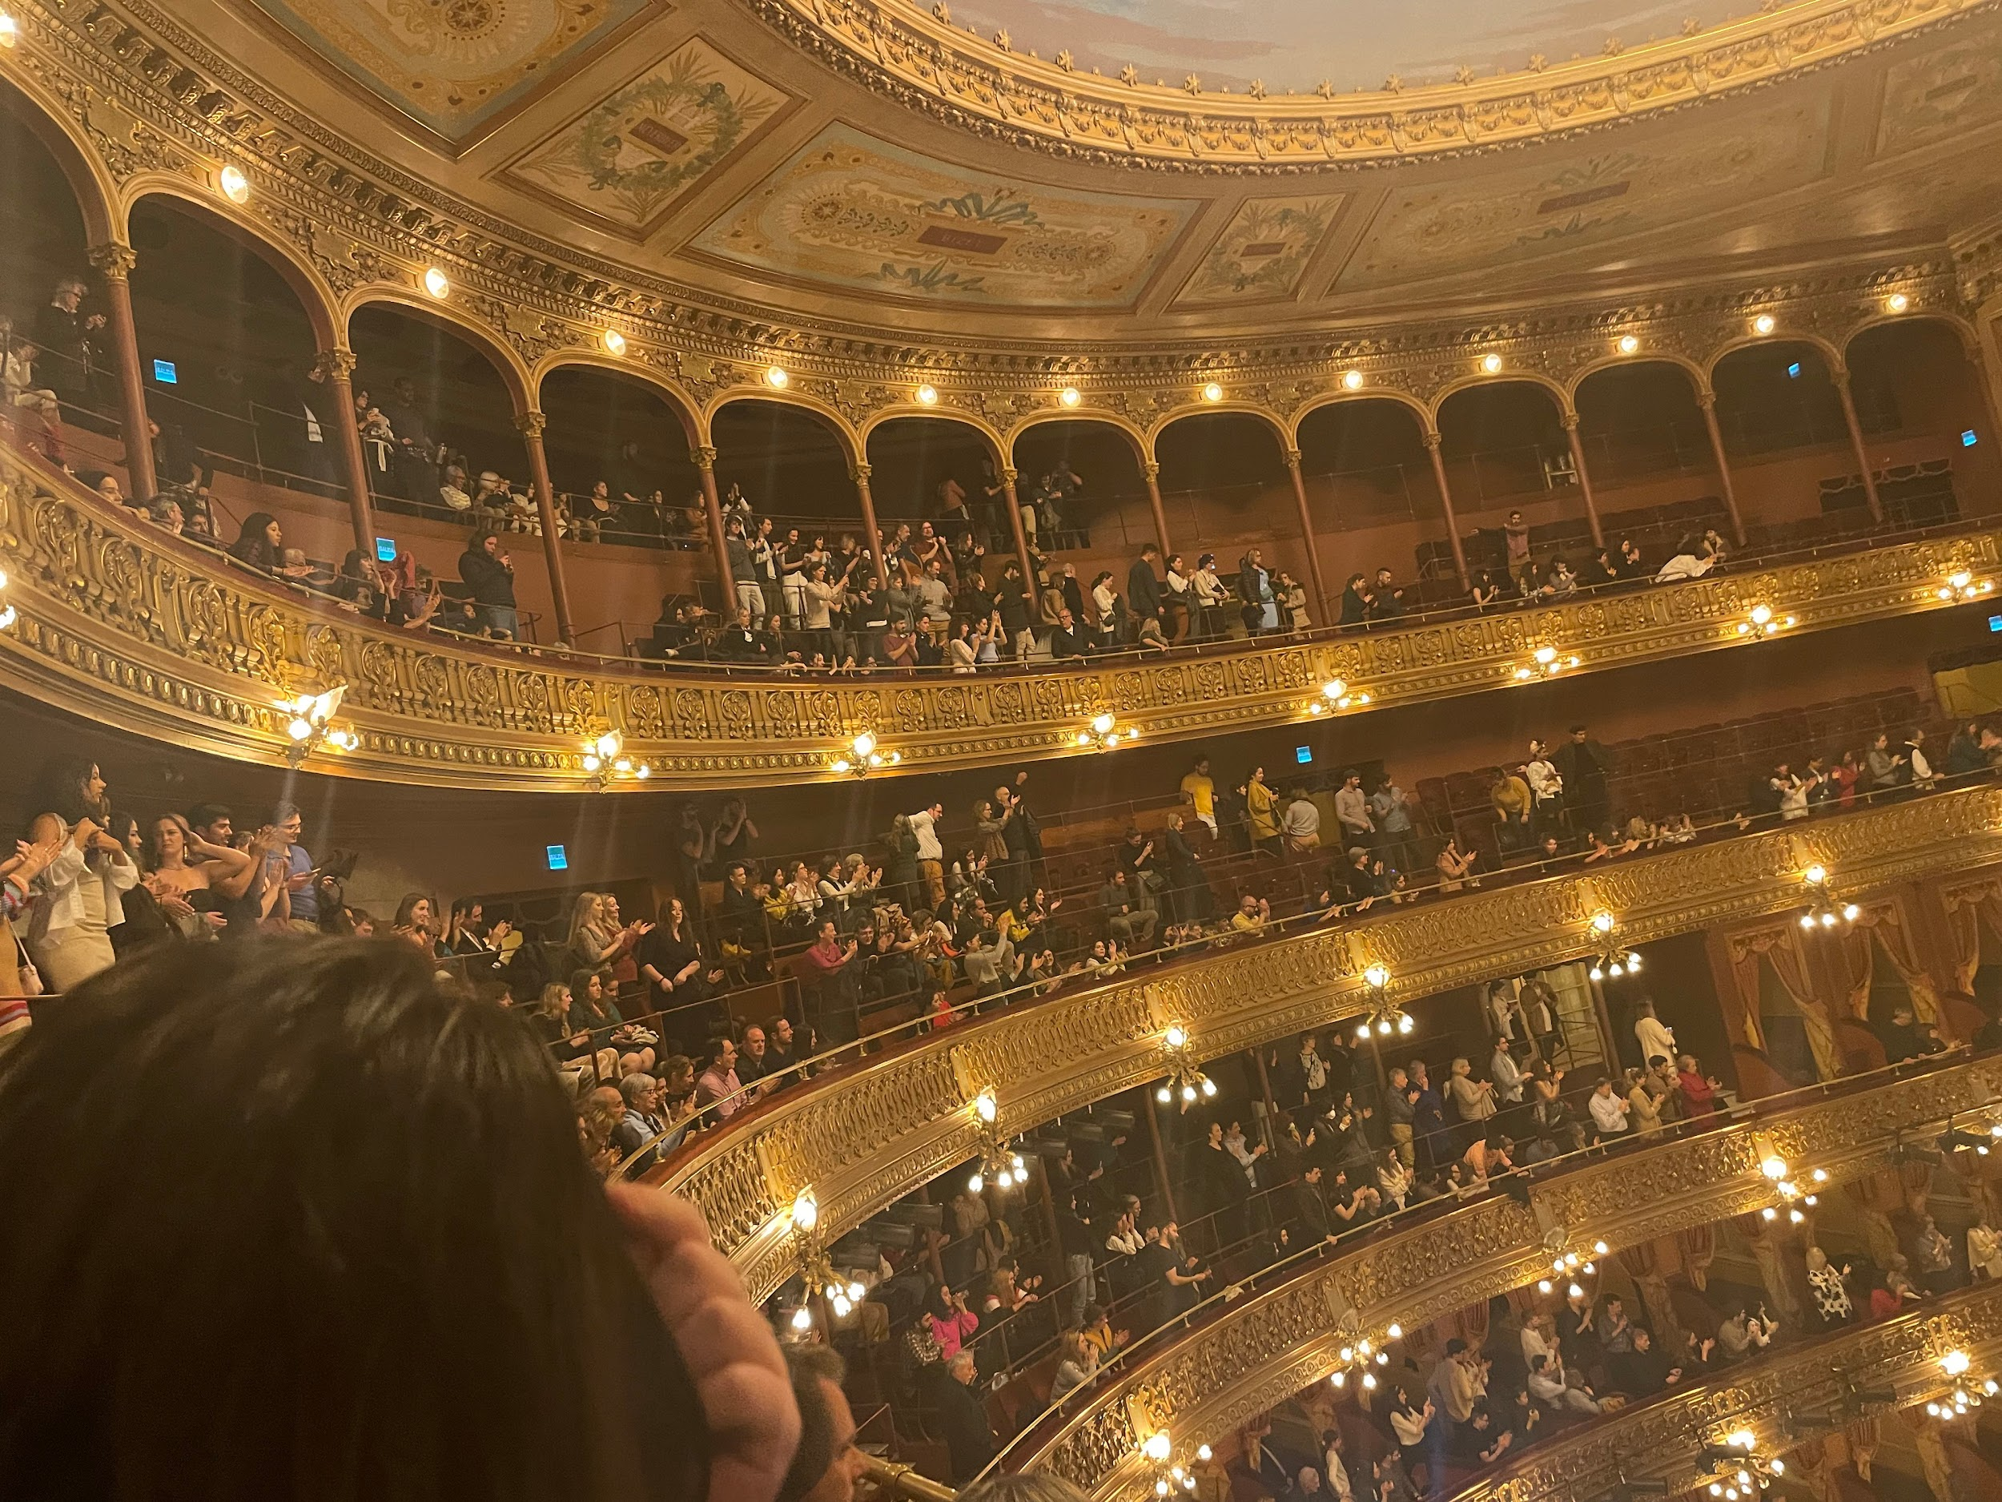
Teatro Colón. Both the biggest and most beautiful concert hall I have ever visited. It was breathtaking.

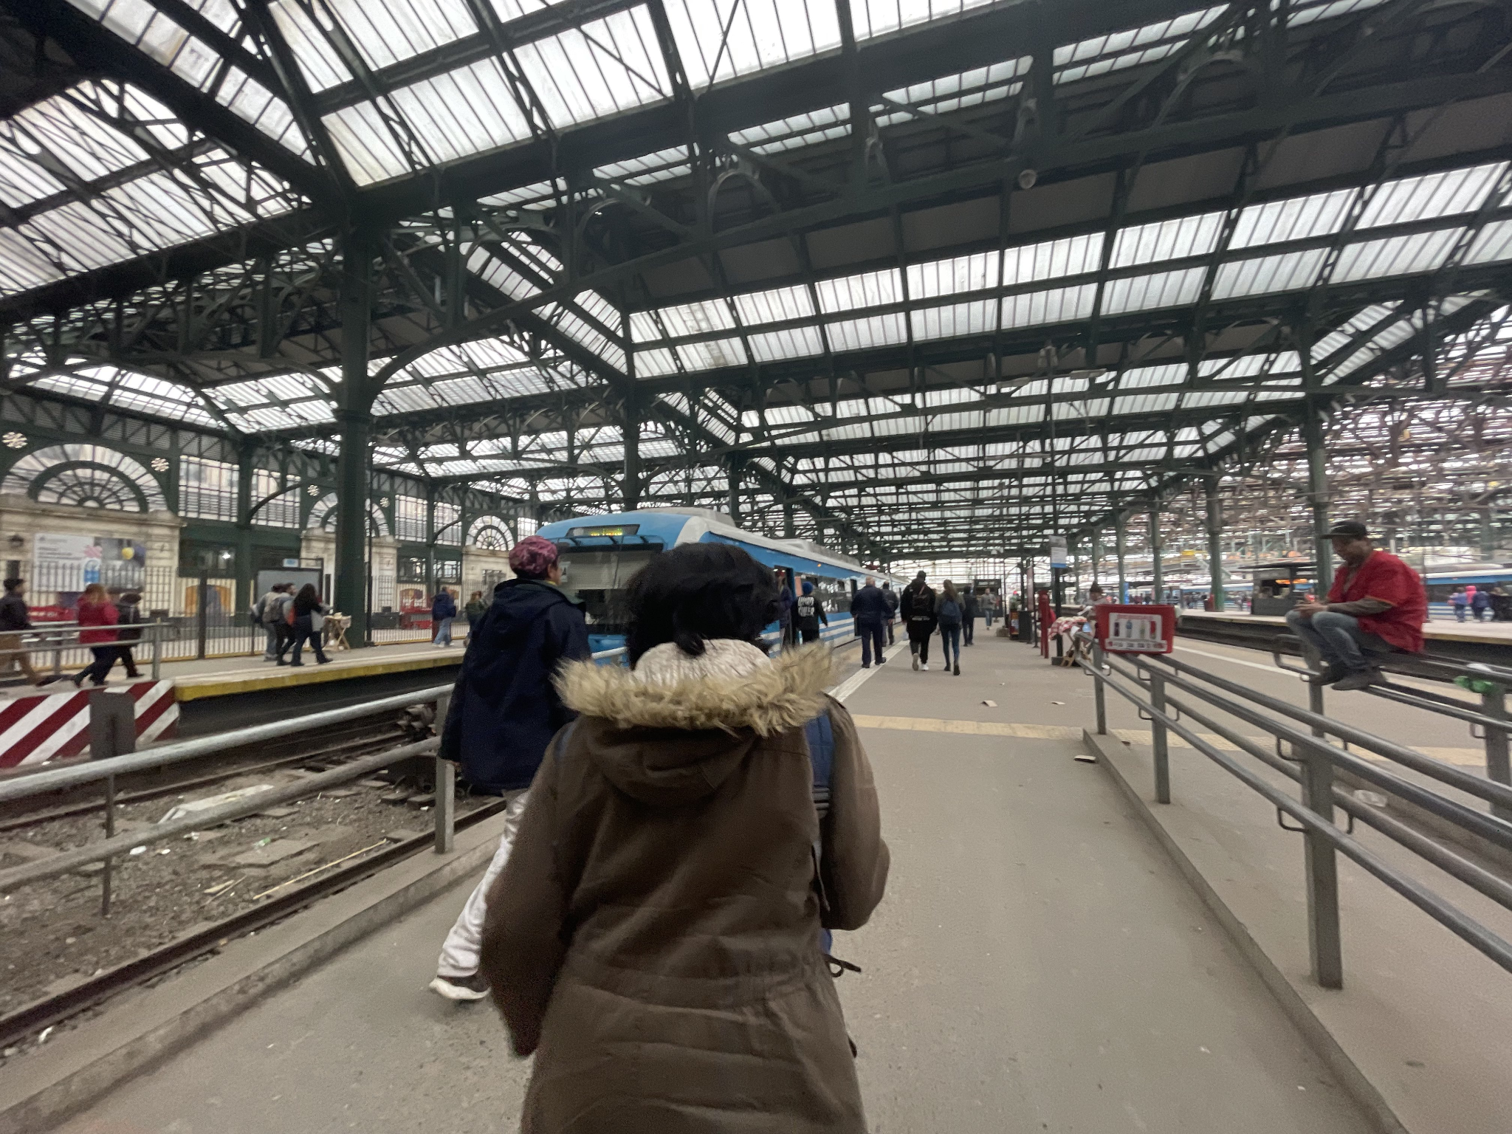
Trains from Constitución to La Plata. Constitución is… rough. Very high crime neighborhood. Every time I was there I saw prostitutes. I utterly refused to take Uber to master Buenos Aires public transport and walked around there with my bassoon to get to La Plata a couple of times. Probably not my brightest move. That being said, no one ever tried anything on me. No one really questions a young girl who looks Latin American (my parents are Peruvian and Nicaraguan) walking around by herself. I was not read as Argentine, however. I was frequently asked if I was Brazilian.

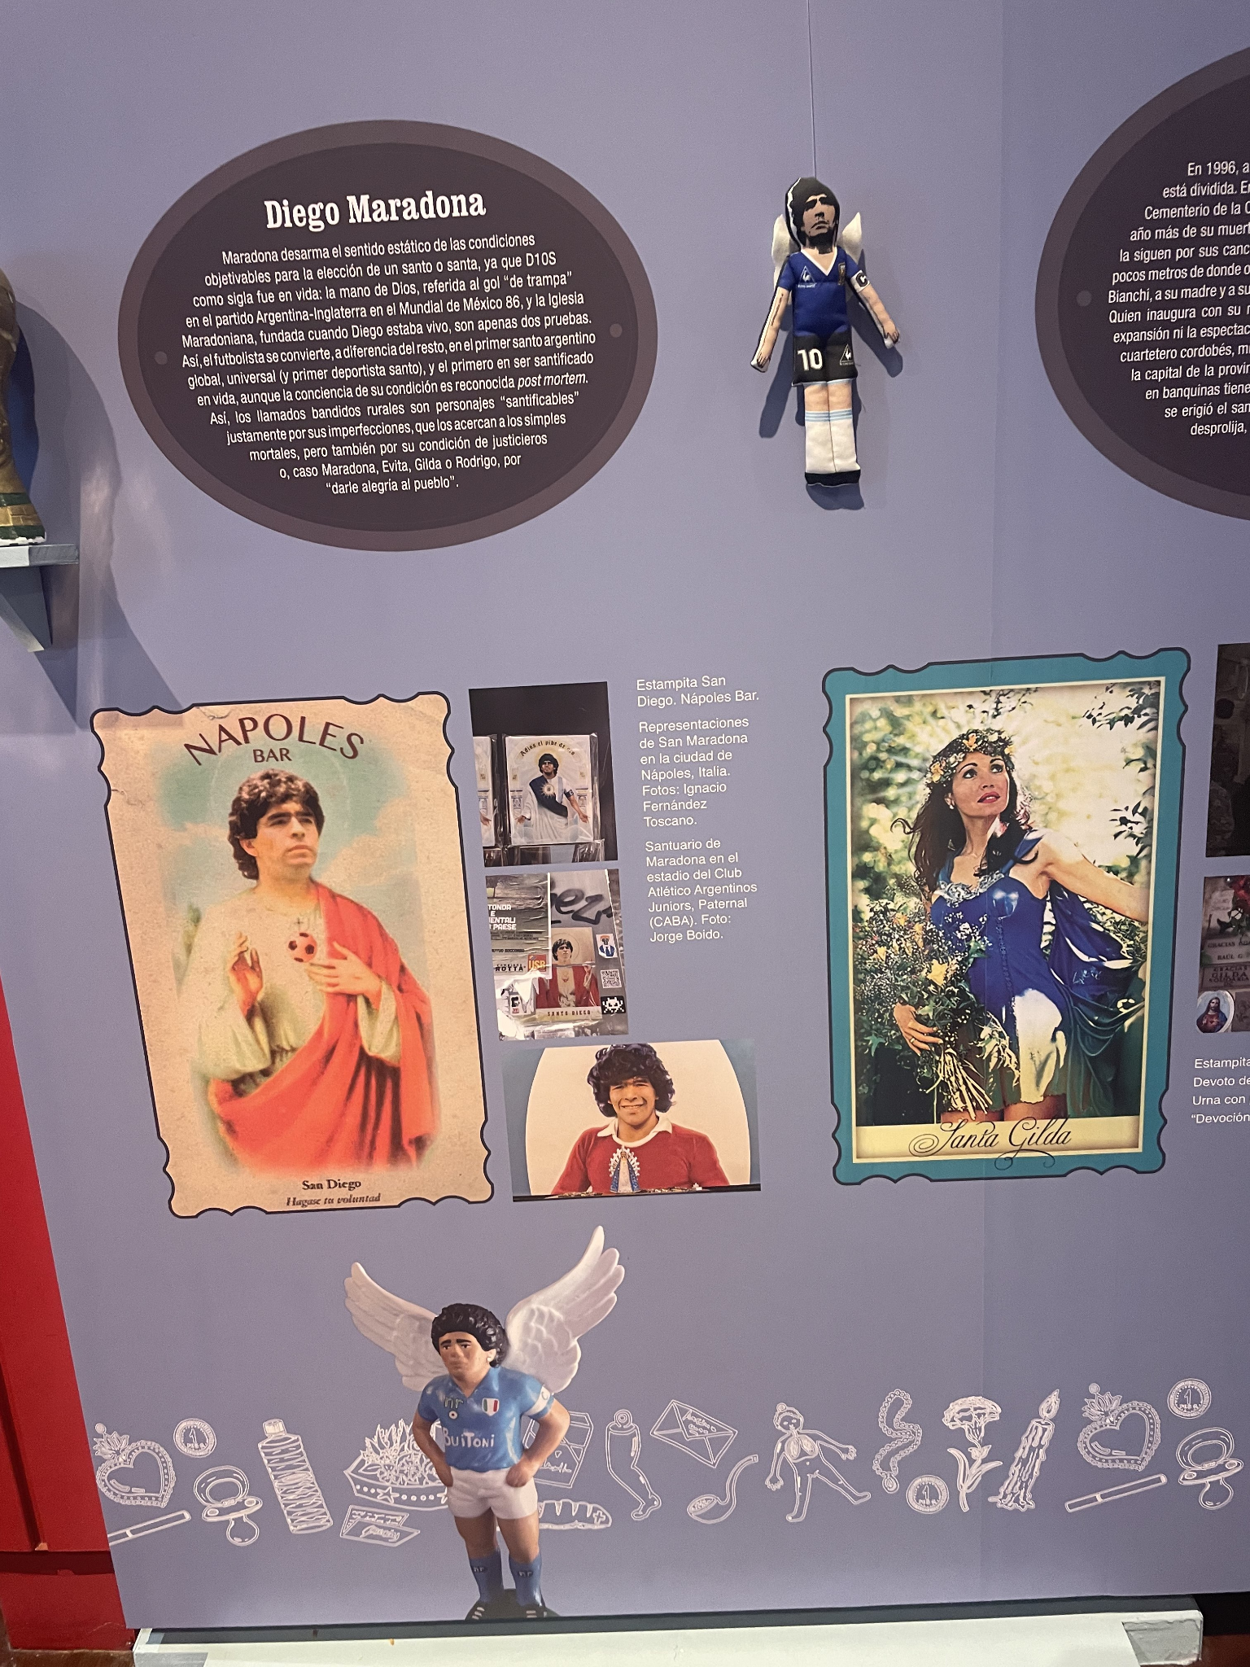
Catholicism in Latin America is always interesting. I saw a lot of religious iconography around Lionel Messi, Diego Maradona, and Eva Perón. This is from an exhibit on religion in the national library of Buenos Aires.

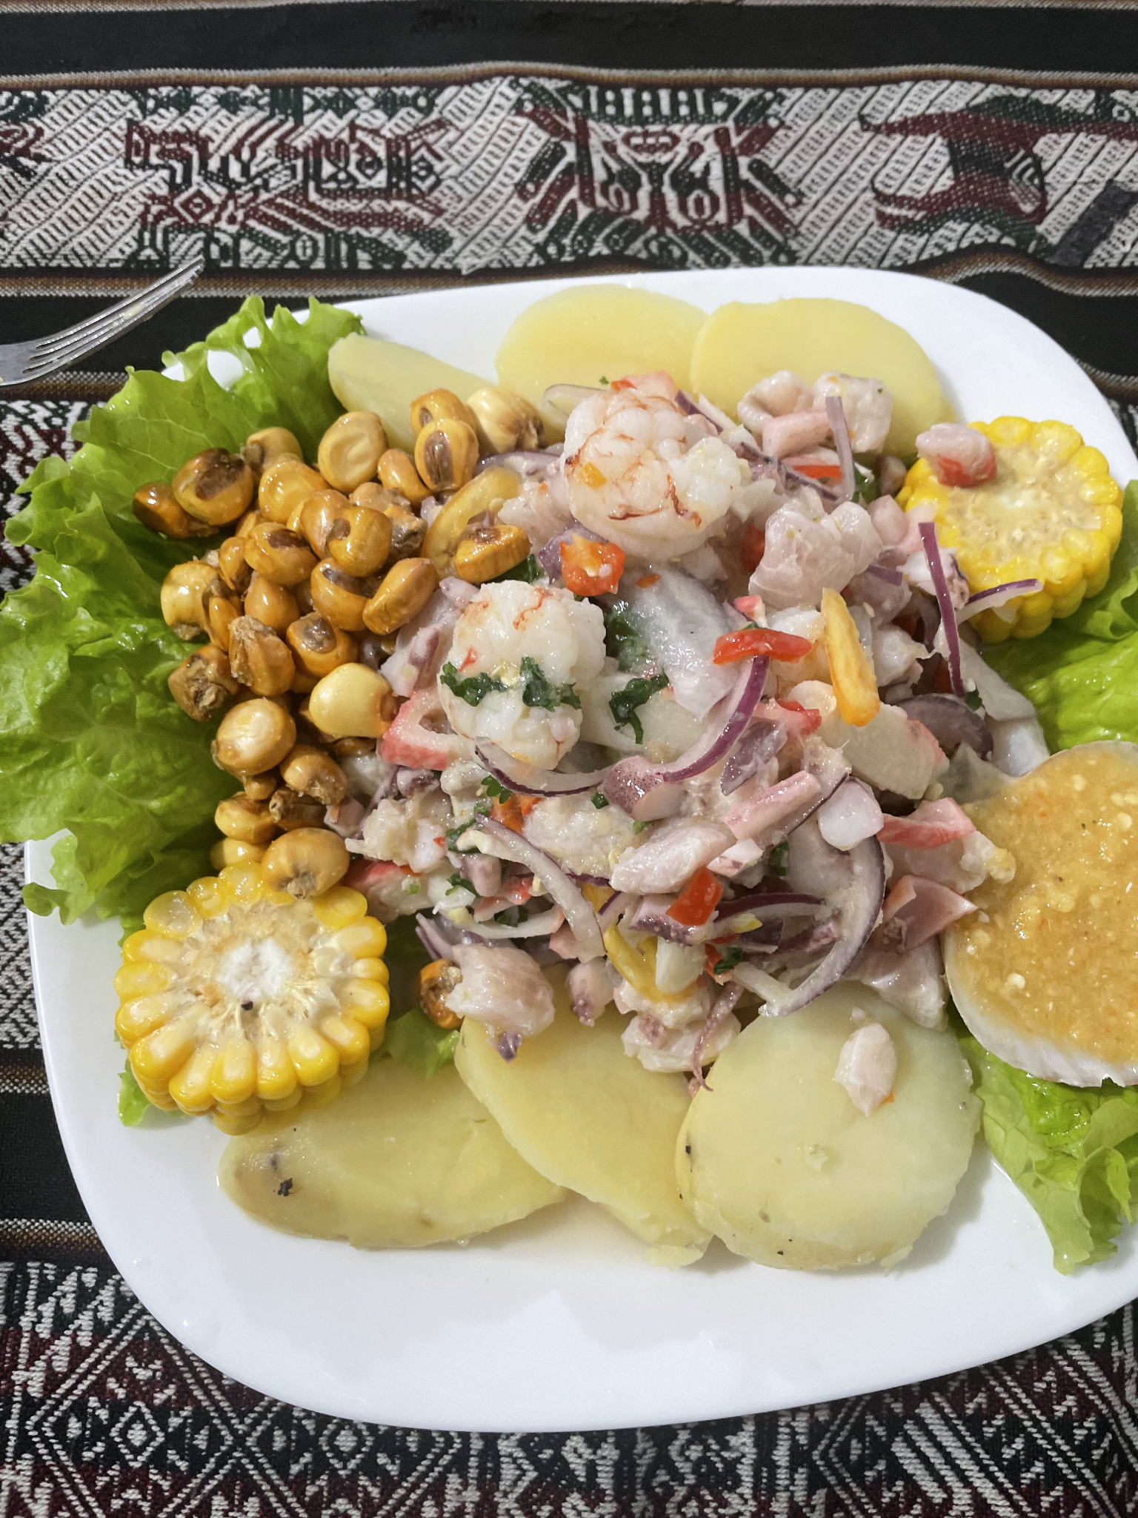
Ceviche, a Peruvian dish. Peruvian food has a great reputation in Latin America and you can find many luxury Peruvian restaurants in Buenos Aires. Buenos Aires is a very global city, with current immigration trends being from nearby South American countries, notably Bolivia, Peru, Paraguay, Uruguay, and Brazil. There is also a very notable history of mass European immigration to Argentina which is obvious in everything from the diverse architecture to the names of the people here. It even goes beyond Europe and Latin America. There is a Chinese enclave, a Korean enclave, and a significant number of Senegalese people in the city.

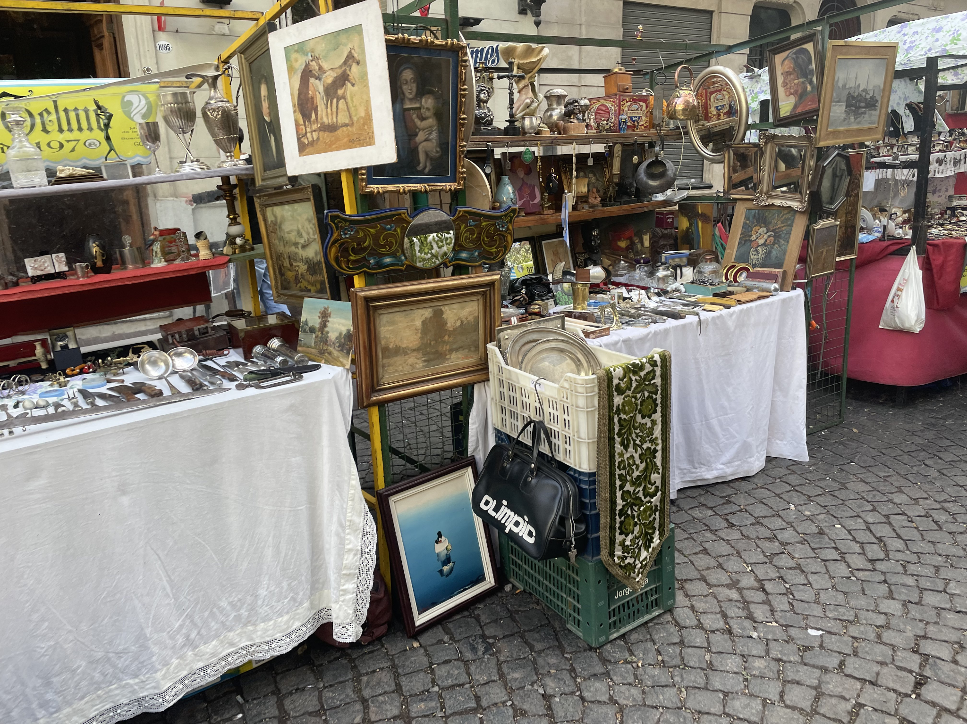
San Telmo Antiques Fair. The biggest concentration of English speakers I saw in Buenos Aires. Vendors price items in USD here. USD is often used not only for its universality but also for its stability when compared to the Argentine Peso.

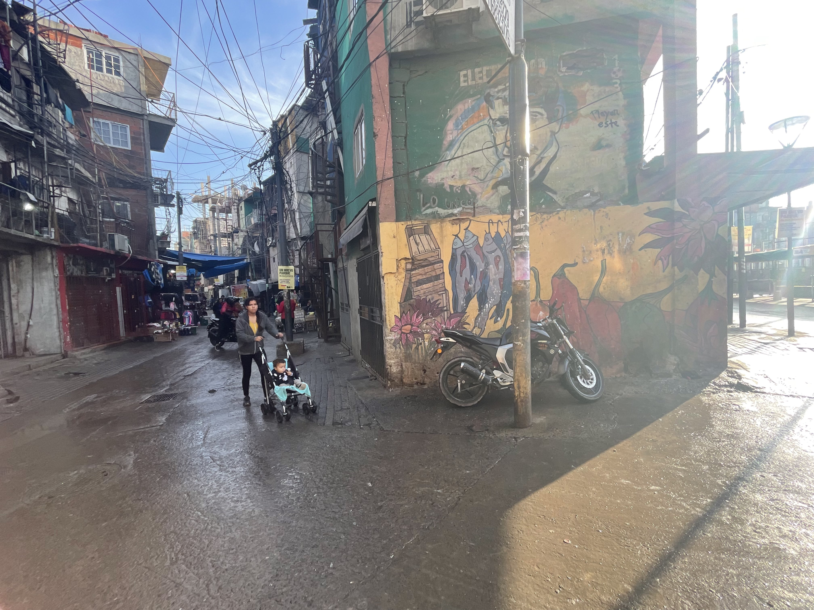
Barrio Mugica, more commonly known as Villa 31. “Villa” is the word used to describe dense slums across Argentina. I took a private tour of the neighborhood and became great friends with the tour guide. We ended up staying hours beyond what we originally planned. I came back to the villa by myself, having memorized the layout of the entire neighborhood, to attend his music classes. He invited me to an asado in the community. This was my last sight of Buenos Aires before I had to rush to the airport: https://www.youtube.com/watch?v=EmI7SPL6EnI

