Facts about Abortion in America*

*Unless specified otherwise, data presented here comes from the Guttmacher Institute surveys and fact sheets.

Why does the issue of abortion affect you?
Nearly one in four women in the United States (24%) will have an abortion by age 45. Nearly half (45%) of all pregnancies among U.S. women in 2011 were unintended, and about four in 10 of these were terminated by abortion.
How many abortions are performed in America?
Approximately 930,160 abortions were performed in 2020, an 8% increase from 862,320 in 2017, reversing a decades long decline in the number of abortions. In 2020, 1 in every 5 pregnancies in ended in abortion, about half the number of pregnancy terminations in 1981.
What is the breakdown by age of women who obtain abortions?
The majority of women having abortions are in their 20s and account for approximately 60% of all abortions.
- Women ages 20–24 (34%)
- Women ages 25–29 (27%)
Teens account for 12% of all abortions (2014). Most have abortions in their older teens (18-19 - 8%). The number of teens having abortions has declined by about half since 2008. This difference is attributed to improved access to and use of contraception among adolescents.

What is the demographic profile of women who obtain abortions?
  - White women account for 39%, African Americans 28%, Hispanics 25% and all other ethnicities 9%.
  - In 2014, 1 in 10 abortion patients had incomes below the federal poverty line ($11,670 for a single woman with no children).
  - This same study found that 53% of patients paid out-of-pocket for their abortion and 24% used Medicaid.
  - In 2014, 59% of women seeking abortion had at least one previous birth; 41% had no prior births.
  - 5 out of 10 women who have abortions identify as being religiously affiliated (17% Mainline protestant, 13% Evangelical Protestant, 24% as Catholic, and 38% had no religious affiliation).
  - Women who’ve never been married and are not cohabitating account for 46% of all abortions.
  - In 2014, 51% of abortion patients were using a contraceptive method in the month they became pregnant.
  - The survey asked about sexual identity and found that unintended pregnancy is not limited to heterosexual women (94% of abortion patients identified as heterosexual or straight, 4% as bisexual, 1% percent as “something else” and 0.3% as homosexual, gay or lesbian).

What are the reasons women have abortions?
- Not ready for a(nother) child/timing is wrong (25%)
- Can’t afford a baby now (23%)
- Have completed my childbearing/have other people depending on me/children are grown (19%)
- Don’t want to be a single mother/am having relationship problems (8%)
- Don’t feel mature enough to raise a(nother) child/feel too young (7%)
- Would interfere with education or career plans (4%)
- Physical problems with my health (4%)
- Possible problems affect the health of the fetus (3%)
- Was a victim of rape (0.5%)
- Husband or partner wants me to have an abortion (0.5%)
- Parents want me to have an abortion (0.5%)
- Don’t want people to know I had sex or got pregnant (0.5%)
- Other (6%)

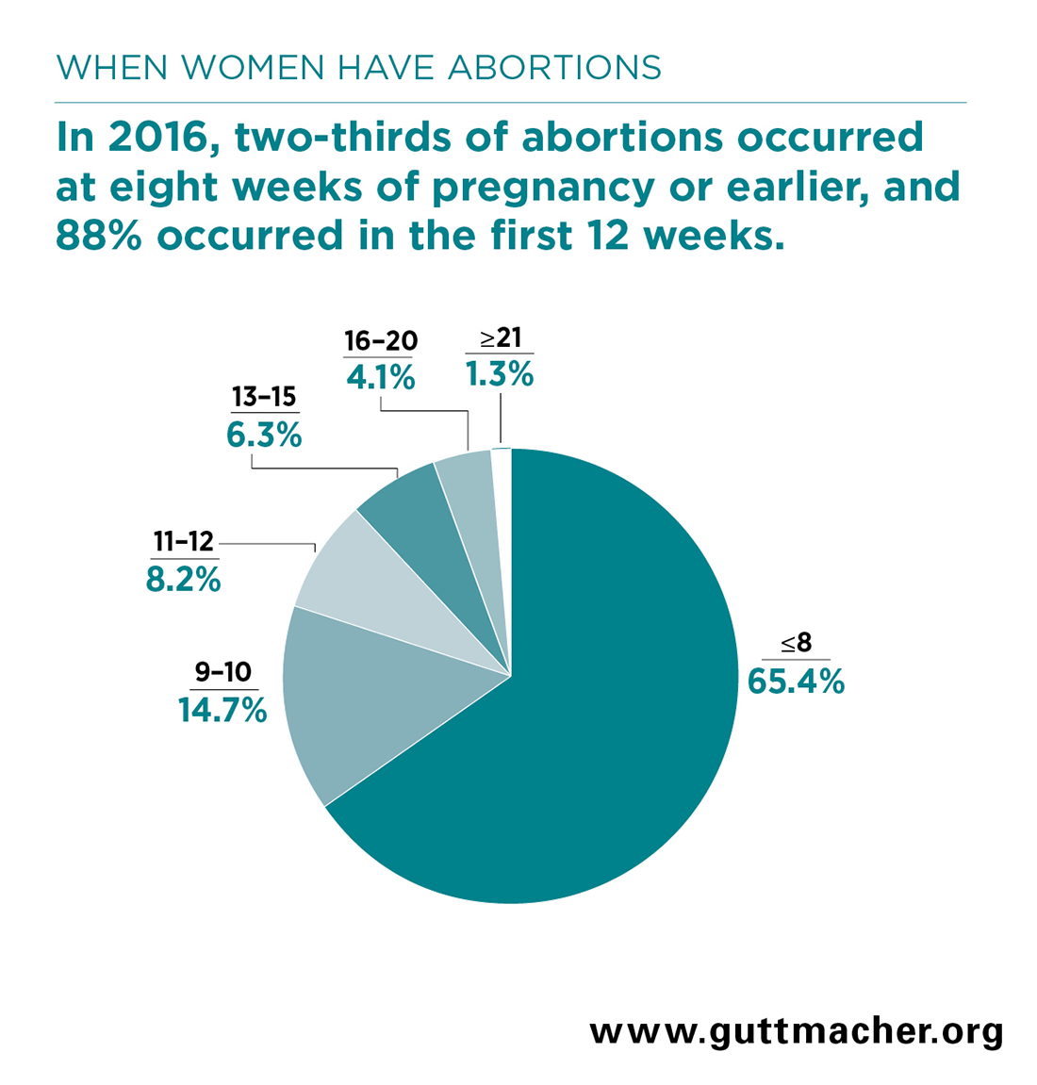
At what point in pregnancy do abortions occur?

Preliminary data from a 2020 study show that 54% of abortions occurring within the first 9 weeks are medical abortions.

Which States Ban Abortion?
As of September 2022 these states had enacted abortion bans:**

**Source: The New York Times, Updated Sept. 23, 2022, 7:30 P.M. ET
What happens when a woman is denied an abortion?***
  - Denying a woman an abortion creates economic hardship and insecurity which lasts for years.
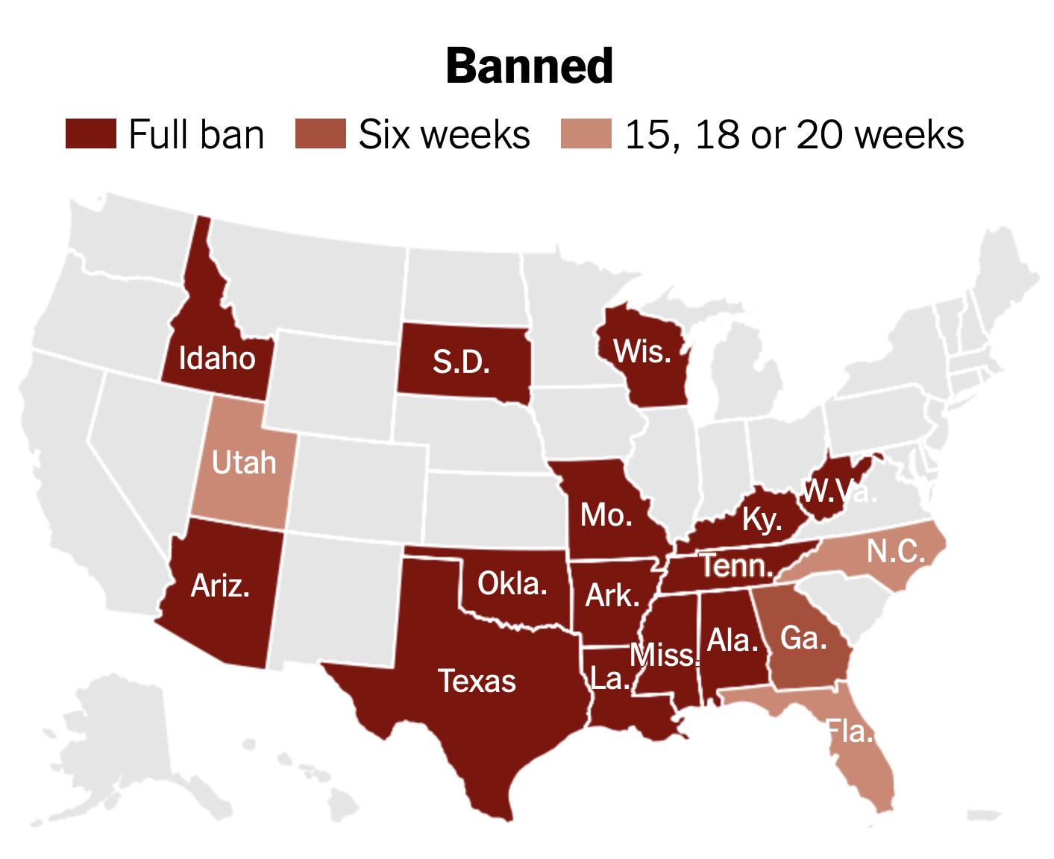
  - Women denied an abortion had almost 4 times greater odds of a household income below the federal poverty level and 3 times greater odds of being unemployed.
  - Women denied an abortion are more likely to stay in contact with a violent partner. They are also more likely to raise the resulting child alone.
*** Source: The Turnaway Study, ANSIRH, University of California, San Francisco.

