# Workshop Summary Report

# Ecosystems and Ecosystem Services Information for Decision Aiding

**Held in**

**Vancouver BC, 14-15 August 2013**

## Overview

In August, 2013, the Center for Climate and Energy Decision Making (CEDM) at Carnegie Mellon University held a workshop titled “Ecosystems and Ecosystem Service Information for Decision Aiding”; it was held in conjunction with researchers at the Institute for Resources, Environment and Sustainability, at the University of British Columbia, which is affiliated with the CEDM. The workshop was attended by researchers from the United States and Canada, who were invited because of their expertise and interest in the topic (a participant list is at the end of this document).

This workshop was the latest in a series of *Theory and Methods* workshops conducted by the CEDM under its support from the US National Science Foundation. Each of these workshops is intended to explore an emerging and potential controversial topic, including its underlying concepts and its applications. The workshops pay particular attention to the relevance of the findings for the Center’s mission and current projects. Previous workshops have led to a variety of research outputs, and helped shape the Center’s research agenda in a variety of contexts, including the *rebound effect*, and treatment of uncertainty in climate science.

The purpose of this present summary report is to document in broad terms the presentations and discussions that took place over the two days in Vancouver. It also provides key ideas and points that were stimulated by conversations in the workshop. For more detailed information, notes on each individual session have been compiled and are available upon request. This report is *not* intended to serve as a deliberate plan or foundation for future research efforts by the CEDM or others. Rather, ideas for next steps and outputs are outlined briefly at the end of the report.

In broadest terms, the workshop was held to consider and reflect on key issues that have concerned observers of US-based approaches to decision making about rules, resource allocations and regulation. These concerns include our observation of a diminishing commitment of federal agencies toward ecosystem research in broad terms, and an ever growing commitment by those agencies (and many researchers) to commodify ecosystems in terms of the services they provide to humans. These values are typically quantified by using welfare economics concepts to measure market-surrogate values associated with these *ecosystem services*.

The theme we developed for the workshop was:

*Beyond benefit transfer: Augmenting valuation and decision aiding concepts for Ecosystems and Ecosystem Services.*

This theme reflects our desire to (i) move beyond the *current flawed benefit transfer approaches to representing ecosystem service values,* in order to (ii) pursue an *enhanced set of concepts and methods for supporting public decisions* that affect the future of ecosystems.

We sought to augment and construct approaches to values, valuation and decision aiding for ecosystems and the services they provide to humans. The hope is that new approaches can help ensure future public decisions are better structured to provide improved guidance as to the tradeoffs that choices entail.

Given the dual emphasis on (i) *improving the basis for public decisions affecting the environment*, and (ii) the *concepts and methods used to gather and structure value-based information for those decisions*, the workshop sessions provided a rich mixture of decisions contexts, concepts, methods, and applied experience.

The following sections provide a topical summary of key themes and discussions at the meeting. These sections are followed by a series of appendices including the agenda, participant list, and resources as provided by participants during the workshop. A session by session breakdown of topics and their guiding questions can be found in Appendix B.

**Workshop Structure**

The workshop was designed in terms of four basic components, each requiring roughly half a day in the two-day agenda.

1.) We wanted to establish the current state of the art in valuation and decision aiding for environmentally important choices. The group reviewed and discussed the 2012 report prepared for the US EPA Science Advisory Board, and related comprehensive reports on environmental valuation (particularly in the context of ecosystem services).

2.) Next the group proceeded based on the recognition that major current US federal policies require benefit/cost analysis based on welfare economics (under a series of executive orders). Given that legal framework, what scope exists for improving the basis for decision making for those federal agency contexts, with or without explicit valuation in dollar terms?

3.) Then the group adopted a more open, “blue-sky” discussion on methods and approaches that do not directly rely on cardinal valuations for environmental and ecologically important outcomes.

4.) Finally, discussion turned to the key messages and insights from the meeting, and how these are dependent on decision contexts and many other variables. We sought ways of communicating the findings for follow up by the CEDM and other interested parties.

## Summary of Workshop Assumptions, Discussions, and Key Takeaways

We began by accepting the general proposition that the ecosystem service (ES) concept has the potential to provide a more informed basis for decision-aiding related to resource management and ecosystem service valuation in particular. The goal of the workshop was to discuss the shortcomings of the ES valuation approaches in this context, using an EPA Science Advisory Board (SAB) report on the topic as a starting point. The group’s initial task was to offer recommendations on how to improve the SAB report or offer reasons why ES valuation has limited applications in the structure within which it needs to generate persuasive evidence. What follows is a general summary of the two day workshop. A session by session breakdown of topics and their guiding questions can be found in Appendix B.

Presentations

Presentations in the main sessions focused on limitations related to existing valuation approaches, and led to discussion of potential means to remedy the limitations but also the uptake of the good ideas that have been recommended and promoted. The guiding questions that led each session are in the agenda in appendix B, detailed notes on the presentations are available, what is represented below are the collective takeaways from both the presentations and discussions, as agreed upon by the group. The tables in appendix A are intended to support these points.

## Key Insights from the Discussions

## Effective decision aiding for environmental choices does not necessarily require explicit cardinal valuation

* The discussions at several points stressed that practical approaches are available to focus decisions as choices among alternatives, rather than relying on approaches that infer market-like values, to simulate a market outcome where no market exists. The market analogy for public sector decision aiding has its roots in the public finance rationale for government involvement in markets in general. But a great many important policy decisions cannot be successfully, insightfully, or sensibly addressed with this market analogy. Much of ecological and environmental economics touches on different perspectives regarding these issues. Here we suggested stepping back from trying to simulate what a (non-existent) market would provide, and instead ask: “What is a wise public policy choice to serve the short and long term common good, given the alternatives we have created”?
* Natural resource damage assessment is one context where explicit dollar evaluation of resource losses is no longer used. Instead the recent approach has been to focus on characterizing what resources and ecosystem services were lost (from, say a toxic spill) and characterize those losses in “natural units” (measures that have common meaning, such as hectares, or tonnes). Various kinds of biophysical research may be done to consider the ecological and/or social functions of the resources in question. Then sets of alternatives are created, compared and ultimately one selected by a trustee or group of trustees as appropriate compensation for the resources lost. Thus the focus is on creating and comparing alternatives to address and compensate for the losses suffered.
* Another context in which explicit cardinal valuation can be avoided, but useful information achieved, is with what might be termed *pair-wise comparison*. In this approach, two resources are compared, one of which is well defined in dollar terms (call it resource A) and one is not (resource B). Then simply asking a decision maker to compare which is more important to them, obtaining resource A or B, can provide a ordinal valuation of B compared to A. Then the dollar value of A is a guide to the relative value of B. This method is one example of how the methods of preference elicitation from decision analysis can be used to infer values that are sufficient to select a preferred alternative, even without a complete cardinal valuation. A paper by McDaniels and Trousdale (2005) used a version of this approach in valuing losses of culturally important resources used by indigenous people.
* A variant of the approach just outlined has been applied in past (as far back as the early 1970s) within the environmental economics canon. It is most easily discussed in terms of a decision regarding preservation or development of an area. In many cases the costs of foregoing development (e.g., foregoing the dollar gains of resource exploitation) are relatively easy to characterize, and often remarkably low. Once these costs of foregone development are quantified, one can then reasonably ask whether the unquantified benefits of preservation (in terms of biodiversity preservation, ecosystem service provision, or anything else) outweigh the dollar benefits to be obtained through resource exploitation.
* These points all turn to some extent on the question of the appropriate “level of measurement” (Krantz, Luce, Suppes and Tversky, 1971) for value judgments regarding the significance of specific environmental resources for human societies. In general the writers cited above argue that simpler, less demanding levels of measurement are superior when seeking to make judgments about values or differences in utility. They would argue that pair-wise comparisons have the least complex judgment tasks, while ordinal ranking is more complex, and cardinal valuation is the most demanding and complex. Good elicitation practice calls for first using pair-wise comparisons, then ordinal comparisons, and finally cardinal measures, but only if needed.
* These points are all potentially valuable for future discussions about decision aiding that does not adopt the market analogy for public decisions.

### Clear ES definitions and assumptions are fundamental and necessary to make progress

* The term “ecosystem services” represents one way to conceive of the benefits humans derive from natural resources. Often in policy settings ecosystem services are thought of strictly in the context of valuation, and valuation is thought of strictly in the context of monetary valuation. Broadening this view point and considering valuation does not necessarily refer to converting everything to a common (dollar) unit is important. (See the discussion above).
* ES have utility as a metaphor that is at the risk of being subverted by the popularity of neo-classical ideology.
* The term “cultural ecosystem services” brings with it many embedded assumptions, and as a result:
  + Recognition and representation of moral values are critical, although they cannot always be linked to bio-physical services.
  + Bio-physical services can often be directly related to cultural benefits and their valuation.
  + Values expressed by certain demographics (e.g., “cultural groups” are not necessarily Cultural Values).

### Process matters for all efforts at characterizing public values for ecosystems

* The current economic valuation methods do not contribute to (and perhaps detract from) the development of strong and on-going governance of natural resources.
* When using an ES evaluation framework for a decision making process, it is crucial to consider how access to ES benefits as well as to information about them is embedded and dependent on pre-existing governance structures and power distribution among the interested constituencies.

### The Social-ecological systems in which decisions are made are dynamic

* Evolving contexts and values must be considered
  + Uncertainty and surprises are under-appreciated
  + Expert elicitation from local experts and scientists is under-utilized (particularly when we consider that uncertainty and surprises are increasingly common)
* To support or in lieu of model predictions, given substantial uncertainty, more attention could be focused on various scenarios explored for consideration of possible outcomes and their implications.
* There is a limit to what we can know about a given system and its interactions- biases and assumptions embedded in valuations should be clear to those using the tools as well as those using the data for decision-support
* There is a limit to what we can generalize across settings in which valuations take place

### Context and scale dictate the use of different methods

* Currently there is a mismatch between available ecosystem data (more common locally and regionally)and where there is a demand for information(often global assessments receive the most attention despite relying on disparate data and less defensible methods).
* Ecosystem services valuation methods are a poor fit to comprehensive assessment of impacts except at the smallest scale (though to reinforce the above point, it is often assumed and requested that these techniques apply at a very large – often global – scale).
* Benefit transfer is commonly used for large scale estimations of value (eg. Costanza et al., 1997), and does not do a good job of reflecting local realities.
* There is a mismatch between economic and ecosystem services methods and the decision-making process
  + The economic methods are a poor fit for many environmental problems we face, that are non-marginal & non-substitutable.
  + In many cases metaphors other than utilitarian production better represent stakeholder basic values
* Certain settings are highly structured and which limits the flexibility within which we can act (eg. if one is bound by strict legislation)
  + There is a need to define decision contexts, as certain tools and approaches are more well suited to different settings eg. private contracts, public policy/directives, public-private partnerships, etc.
* Issue of Scale and Frequency – objectives as well as potential actions for resolution differ depending on both of these factors, for which different types of valuation assessments may be appropriate (and in some cases, required by law).
  + Global - for concerns such as climate change, ocean acidification, etc. objective is protection/mitigation
  + Regional – disasters like 1991 Kuwait, 2010 Deepwarter Horizon focus on restoration and punitive damages for specific offenses
  + Local - 30,000/y petrochemical spills in Canada, barters as compensation and mitigation have been effective, but have not been common at larger scales

## **Outputs**

1. Key “take aways” (listed above) were distilled by the group. They can be further adjusted, but they main ideas were put forward in a table, to be elaborated upon in **a short piece that summarizes the overall findings of the workshop**.   
   Coordinator: Paige Olmsted.

A lot of conversation surrounded cultural values and how they are or are not integrated (and that cultural services as currently stated are not particularly useful/accurate way to think about many of the intangible benefits of nature), but many of those present have already written extensively on this issue. It is likely not something to delve into in this piece in a way that it could be adequately covered, so the question would be whether it would merit it’s own output, or if we were treading on territory that is generally already understood.

1. The limitations of Benefit/Cost Analysis (BCA) in the US Context.   
   Lead: Granger Morgan and CMU team. (Note: this paper has already been submitted)
2. “Defining values is a political act”.   
   Lead: Tim McDaniels and interested participants from the workshop

Further outputs, perhaps focused on one or two key elements from the attached table are certainly welcome, please contact each other or you are welcome to use Paige as a coordinator for such an effort. We hope that this was a stimulating, thought provoking, and will prove to ultimately be a worthwhile two days for all involved.

## Appendix A: Tables

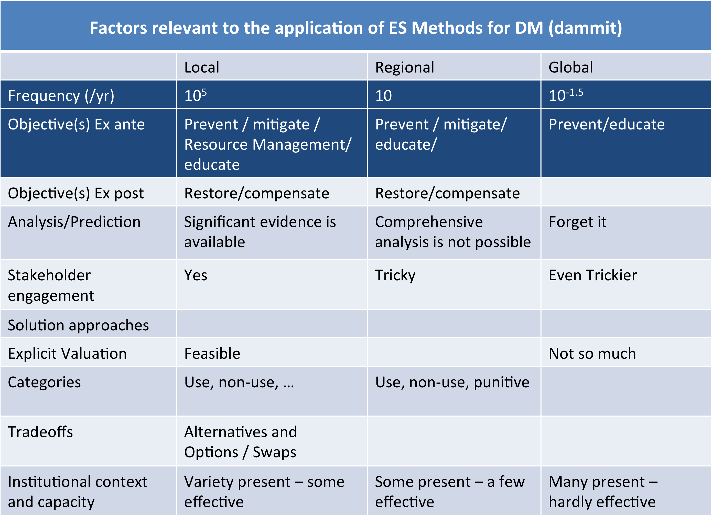

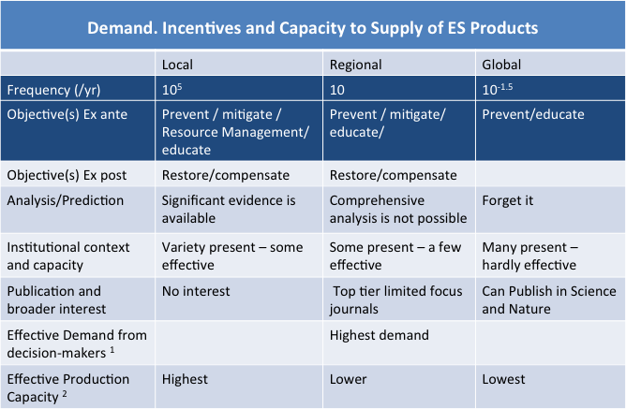

## Appendix B: Abbreviated Workshop Agenda

**Day 1, Wed Aug 14**

**Morning session: SAB report: State of the Art?**

***How well are we doing in terms of concepts and practice for decision aiding in representing ecosystems and ES for resource management issues?***

0915-1045 1. *Review and critique of SAB Report*

In this session, we prime and invite workshop participants to review and critique the SAB Report in how ES should tackle:

* Intangible / cultural / less quantified values
* Uncertainty
* Ignorance (a.k.a. information gaps).

This initial set of conversations will help shape the conversations that are planned for remaining sessions of the workshop.

Participants: All those who want to speak in one of the subsequent sessions are invited offer up some views in this initial session on the state of concepts, practice and art for representing ES and ecosystems.

1100-1230 *2. Dealing with Uncertainty in ES decision-making*

**Moderator: Mark Johnson**

**Discussants: Granger Morgan, Hadi Dowlatabadi, Inês Azevedo, Kai Chan**

Guiding Questions: How can we better address uncertainties and represent linkages across scales when considering the impacts of a change in land/water/air resources that will affect ecosystems and ecosystem services? How can decisions be framed in ways that minimize the extent to which uncertainties are ignored or skirted? How can frameworks be devised that fit with current institutions but cast decisions in ways that are tractable given uncertainties?

The intent is to point toward ways of addressing uncertainty better for decision aiding. If preparing some slides is helpful, no more than 5 minutes, and thus 5 slides per person.

**Afternoon Session: Addressing Gaps in SAB report and ES Decision- Aiding**

1330-1500 3. *Cultural and Deontological values in Decision-Aiding: Where do we stand and can we do better in informing societal decision aiding in terms of these intangible values?*

**Moderator: Rafaelle Vignola**

**Discussants: Bryan Norton, Granger Morgan, Richard Howarth, Terre Satterfield**

Guiding questions: Can values be better integrated into valuation (and should they?) How can cultural values be addressed more effectively? What is the role of intrinsic deontological values and how can they be introduced into current frameworks?

1515-1645 4. *The real world: Legal System, replacement alternatives, other existing valuation strategies (including those proposed/recommended by the SAB)*

**Moderator: Mark Stevens**

**Discussants: Robin Cantor, Robin Naidoo, Mike Griffin, Tim McDaniels**

Guiding questions: How does what we have discussed thus far fit into the existing system? What approaches are currently practiced for valuation within the tort system? How well is replacement value working as a way of understanding and parsing valuation? What is the potential for new laws that build on existing institutional and legal frameworks that can bolster the status tools currently being used and how they can be expanded or what new tools are required?

**Day 2, Thurs Aug 15, 2013**

**Morning Session: Moving Forward: new information, concepts and methods**

0915-1045 *5. New Approaches*

**Moderator: Richard Howarth**

**Discussants: Jordi Honey-Roses, Mark Johnson, Sarah Cooley**

Guiding Questions: What kind of information/processes do we need for new approaches? What information would be effective and convincing within current or future governance systems in helping to better consider ecosystems and ES in societal choices?

How to build the role of multiple objective approaches to analysis, which does change the conceptual basis and measurement units for valuation. How about framing decisions from the view of future generations? Paraphrasing Bryan Norton: How can we address valuation across time and space in which multiple values and scales are embedded?

1100-1230 *6. What if? Thinking about changing the constitution*

**Moderator: Hadi Dowlatabadi**

**Discussants: Bryan Norton, Rafaelle Vignola, Kai Chan, Tim McDaniels**

Here we consider more explicitly the notions of different governance structures, and different ethical and value structures. We want to address alternative frameworks, wild ideas OR “overflow” session for anything that has run out of time earlier that had a lot of traction. Kai Chan suggested one question on framing ES valuation as contributing to restorative sustainability. What is needed to get there? Why are we not there now?

**Afternoon Session: What next?**

1330-1500 *What Next?*

Here we have two options: (i) an emergent question selected by the group, to build on what has been discussed, OR (ii) move breakout groups with specific assignments in contributing to a synthesis paper pointing out the issues and ways to address them better.

## Appendix C: Participant List

**Inês Azevedo** Executive Director, Climate and Energy Decision Making

Engineering and Public Policy Department, Carnegie Mellon University

**Robin Cantor** Economist, Berkeley Research Group LLC

**Kai Chan** Associate Professor and Tier 2 Canada Research Chair (Biodiversity & Ecosystem Services), Institute for Resources, Environment & Sustainability, UBC

**Sarah Cooley** Research Associate, Marine Chemistry & Geochemistry

Woods Hole Oceanographic Institution

**Hadi Dowlatabadi** Professor & Canada Research Chair in Applied Mathematics and Integrated Study of Global Change, Institute for Resources, Environment & Sustainability, UBC

**Mike Griffin** Associate Research Professor, Engineering and Public Policy and Tepper School of Business, Co-Director and Executive Director, Green Design Institute, Carnegie Mellon University

**Jordi Honey-Roses**  Assistant Professor, School of Community and Regional Planning, UBC

**Richard Howarth** Professor of Environmental Studies, Dartmouth College, Editor-in-Chief,*Ecological Economics*

**Mark Johnson** Associate Professor Institute for Resources, Environment and Sustainability and Department of Earth, Ocean and Atmospheric Sciences, UBC

**Sarah Klain** PhD student, Institute for Resources, Environment & Sustainability, UBC

**Tim McDaniels** Professor, Institute for Resources, Environment & Sustainability and School of community and Regional Planning, UBC

**Granger Morgan** Lord Chair Professor in Engineering, Director, Center for Climate and Energy Decision Making; Director, Wilton E. Scott Institute for Energy Innovation, CMU

**Bryan Norton** Professor, Philosophy, Science and Technology, Georgia Institute of Technology

**Paige Olmsted** PhD student, Institute for Resources, Environment & Sustainability, UBC

**Terre Satterfield** Director, Institute for Resources, Environment and Sustainability

Professor of Culture, Risk and the Environment, UBC

**Gerald Singh** PhD student, Institute for Resources, Environment & Sustainability, UBC

**Mark Stevens** Assistant Professor, School of Community & Regional Planning, UBC

**Jackie van der Eerden** PhD student, Institute for Resources, Environment & Sustainability, UBC

**Raffaelle Vignola** Director, Latin American Chair of Environmental Decisions for Global Change,

Climate Change and Watershed Program, CATIE

## Appendix D: Links/Bibliography

A range of resources were shared across the group, for your reference the links and descriptions (where it is not obvious) are listed below.

**Papers/Books**

Beierle, T. C. (2002). The quality of stakeholder‐based decisions. *Risk analysis*, *22*(4), 739-749.[The quality of stakeholder-based decisions](http://onlinelibrary.wiley.com/doi/10.1111/0272-4332.00065/full" \t "_blank)

Freeman, D. M. (2010). Implementing the Endangered Species Act on the Platte Basin Water Commons. University Press of Colorado.

Jax, K., D. N. Barton, K. M. A. Chan, et al. (2013). "Ecosystem services and ethics." Ecological Economics **93**(0): 260-268.  [http://www.sciencedirect.com/science/article/pii/S0921800913002073](http://www.sciencedirect.com/science/article/pii/S0921800913002073" \t "_blank)

[http://www.amazon.ca/Implementing-Endangered-Species-Platte-Commons/dp/1607320541](http://www.amazon.ca/Implementing-Endangered-Species-Platte-Commons/dp/1607320541" \t "_blank)

Kareiva, P., Tallis, H., Ricketts, T. H., Daily, G. C., & Polasky, S. (Eds.). (2011). *Natural capital: theory and practice of mapping ecosystem services*. Oxford University Press.

Layzer, J. A. (2008). *Natural experiments: ecosystem-based management and the environment*. MIT Press.

Luck, G., K. M. A. Chan, U. Eser, E. Gómez-Baggethun, B. Matzdorf, B. Norton and M. Potschin (2012). "Ethical considerations in on-ground applications of the ecosystem services concept." BioScience **62**(12): 1020-1029. [http://dx.doi.org/10.1525/bio.2012.62.12.4](http://dx.doi.org/10.1525/bio.2012.62.12.4" \t "_blank)

McDaniels, T. L., & Trousdale, W. (2005). Resource compensation and negotiation support in an aboriginal context: Using community-based multi-attribute analysis to evaluate non-market losses. *Ecological Economics*, *55*(2), 173-186.

<http://www.sciencedirect.com/science/article/pii/S0921800905003125>

Ryfe, D. M. (2005). Does deliberative democracy work?. *Annu. Rev. Polit. Sci.*,*8*, 49-71.[Does deliberative democracy work?](http://www.annualreviews.org/doi/abs/10.1146/annurev.polisci.8.032904.154633" \t "_blank)

Ryfe, D. M. (2002). The practice of deliberative democracy: A study of 16 deliberative organizations. *Political Communication*, *19*(3), 359-377. [The practice of deliberative democracy: A study of 16 deliberative organizations](http://www.tandfonline.com/doi/abs/10.1080/01957470290055547" \t "_blank)

**Other**

Benefits transfer database for case studies and/or methodological ideas.

[https://www.evri.ca/Other/AboutEVRI.aspx#04](https://www.evri.ca/Other/AboutEVRI.aspx" \l "04" \t "_blank)

The Nature Conservancy survey on how the US public views "ecosystem services", benefits from nature, etc.  
[http://www.conservationgateway.org/Files/Pages/key-findings-recent-natio.aspx](http://www.conservationgateway.org/Files/Pages/key-findings-recent-natio.aspx" \t "_blank)

TEEB (The Economics of Ecosystems and Biodiversity) synthesis report and individual chapters

[http://www.teebweb.org/publications/teeb-study-reports/foundations/](http://www.teebweb.org/publications/teeb-study-reports/foundations/" \t "_blank)

A synthesis of approaches to assess and value ecosystem services in the EU in the context of TEEB:

[http://ec.europa.eu/environment/nature/biodiversity/economics/pdf/EU%20Valuation.pdf](http://ec.europa.eu/environment/nature/biodiversity/economics/pdf/EU%20Valuation.pdf" \t "_blank)

The 1985 directive on environmental impact assessment:

[http://eur-lex.europa.eu/LexUriServ/LexUriServ.do?uri=OJ:L:1985:175:0040:0048:EN:PDF](http://eur-lex.europa.eu/LexUriServ/LexUriServ.do?uri=OJ:L:1985:175:0040:0048:EN:PDF" \t "_blank)

**National Academies Reports:**

**Ecosystem Services: Charting a Path to Sustainability:**[www.nap.edu/catalog.php?record\_id=13331](http://www.nap.edu/catalog.php?record_id=13331" \t "_blank)

ES Approach to Deepwater Horizon Spill Report  
http://dels.nas.edu/Report/Ecosystem-Services-Approach-Assessing/18387