<EMPTY><EMPTY>

sharpen the students' quantitative, analytic and communication skills.The fellowship program is designed to prepare students from diverse backgrounds for graduate studies and groom them for professional roles in public service. After completing the Junior Summer Institute, Aponte and Hamilton will be eligible to attend a top public policy graduate school with significant - oftentimes 100 percent - financial support.

"Christian and Nicole are outstanding students and members of the Carnegie Mellon community," said Stephanie Wallach, assistant vice provost for undergraduate education.  "PPIA is a terrific fit for their interests, and it will enable them to develop skills and build close community ties with other talented young people who are genuinely committed to public service."

Aponte, who is majoring in [global studies](http://www.cmu.edu/hss/globalstudies/) and [Hispanic studies](http://ml.hss.cmu.edu/ml/undergrad-hispanicstudies.html), thought the fellowship program would be a great fit for his interests in education and international affairs as well as help him become a more effective leader.

"I am most interested in how public policy and international affairs affect education," said Aponte, who will study at the University of California, Berkeley. "Eventually, I would like to unite my interests by developing educational programs that grant inner-city high school students connections to other high schools across the world, initiating a sort of no-boundaries network between young adults."

Hamilton, an [ethics, history and public policy](http://www.cmu.edu/hss/ehpp/) major, will spend the summer at Princeton University. She is looking forward to life after college and applying what she has been learning in the classroom.

"What interests me most about public policy and international affairs is how no aspect of knowledge or human experience is irrelevant when trying to craft a policy for running a nation or understanding a conflict," Hamilton said. "I love how the more you get into the minutiae of a topic, the more things do become complicated and the more one is able to produce good and effective policy."  
     
  
###

Thursday, March 22, 2012

**Two CMU Students Selected Public Policy & International Affairs Fellows**

**Contact:** Shilo Rea / 412-268-6094 / [shilo@cmu.edu](mailto:shilo@cmu.edu)  
  
PITTSBURGH—Two students in Carnegie Mellon University's [Dietrich College of Humanities and Social Sciences](http://hss.cmu.edu/index.html) have received competitive [Public Policy & International Affairs](http://www.ppiaprogram.org/) (PPIA) Fellowships. Both juniors, Christian Aponte and Nicole Hamilton (below) will attend summer institutes at a top-ranked university to sharpen the students' quantitative, analytic and communication skills.

The fellowship program is designed to prepare students from diverse backgrounds for graduate studies and groom them for professional roles in public service. After completing the Junior Summer Institute, Aponte and Hamilton will be eligible to attend a top public policy graduate school with significant - oftentimes 100 percent - financial support.

"Christian and Nicole are outstanding students and members of the Carnegie Mellon community," said Stephanie Wallach, assistant vice provost for undergraduate education.  "PPIA is a terrific fit for their interests, and it will enable them to develop skills and build close community ties with other talented young people who are genuinely committed to public service."

Aponte, who is majoring in [global studies](http://www.cmu.edu/hss/globalstudies/) and [Hispanic studies](http://ml.hss.cmu.edu/ml/undergrad-hispanicstudies.html), thought the fellowship program would be a great fit for his interests in education and international affairs as well as help him become a more effective leader.

"I am most interested in how public policy and international affairs affect education," said Aponte, who will study at the University of California, Berkeley. "Eventually, I would like to unite my interests by developing educational programs that grant inner-city high school students connections to other high schools across the world, initiating a sort of no-boundaries network between young adults."

Hamilton, an [ethics, history and public policy](http://www.cmu.edu/hss/ehpp/) major, will spend the summer at Princeton University. She is looking forward to life after college and applying what she has been learning in the classroom.

"What interests me most about public policy and international affairs is how no aspect of knowledge or human experience is irrelevant when trying to craft a policy for running a nation or understanding a conflict," Hamilton said. "I love how the more you get into the minutiae of a topic, the more things do become complicated and the more one is able to produce good and effective policy."  
     
  
###

EHPP NEWSLETTER

Spring 2012

http://www.cmu.edu/hss/ehpp/

ISSUE 6, SPRING 2012

Find us on Facebook! http://www.facebook.com/pages/Ethics-History-and-Public-Policy-Major-Carnegie-Mellon-University/133337654822



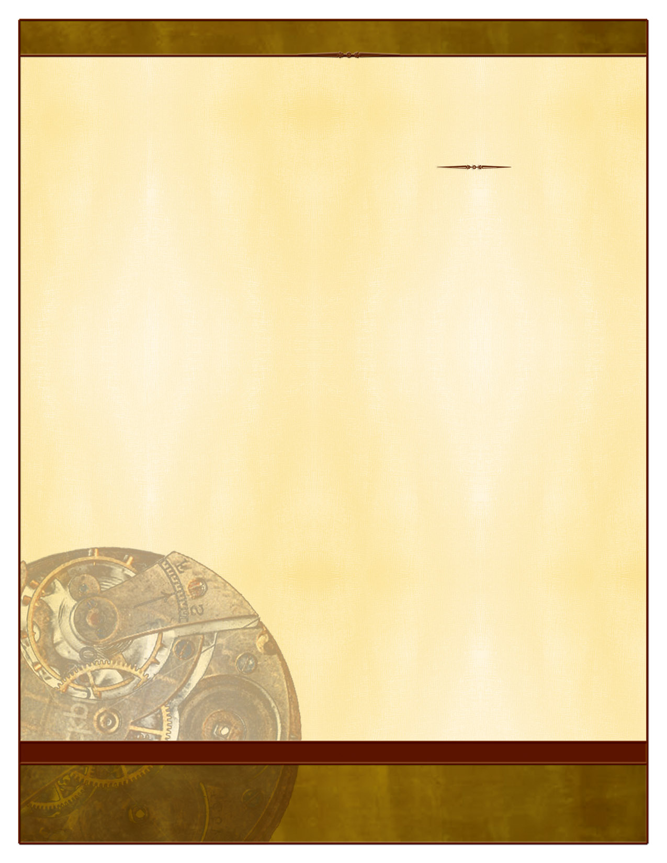

.

.

(PPIA fellows, continued)

Hamilton, an [ethics, history and public policy](http://www.cmu.edu/hss/ehpp/) major, will spend the summer at Princeton University. She is looking forward to life after college and applying what she has been learning in the classroom.

"What interests me most about public policy and international affairs is how no aspect of knowledge or human experience is irrelevant when trying to craft a policy for running a nation or understanding a conflict," Hamilton said. "I love how the more you get into the minutiae of a topic, the more things do become complicated and the more one is able to produce good and effective policy."





Interested in getting involved in the major next year? Please contact Tracy London about joining joining the EHPP Student Advisory Committee (SAC) at [tlondon@andrew.cmu.edu](mailto:tlondon@andrew.cmu.edu). You can help plan speakers, social events, and more!





The Career and Professional Development Center is in the basement of the University Center.  
For more info, check out:  
<http://www.studentaffairs.cmu.edu/Career/>  
phone: 412-268-2064  
email: debraignelzi@cmu.edu

Career and Professional Development Center

If you are looking for an internship or a job, the Career and Professional Development Center is a great ﬁrst stop. EHPP’s advisor is Ms Debra Ignelzi:

## EHPP Career Options (from Debra)

As a Carnegie Mellon University student majoring in Ethics, History and Public Policy (EHPP), it is important to ask yourself several questions when thinking about your future career direction:

-Do I want to further my education after I graduate? If so, how much time do I want to invest in higher education?

-Do I want a job that involves my studies in EHPP?

-What skills do I want to use in my work?

-Do I want to work domestically or internationally?

-Do I see myself working for a big corporation, a smaller company, government, non-profit or NGO?  Or, do I want to be my own boss?

- Is a high salary a priority for me?

When considering the total salary of a job or career, make sure that you take into account what the cost of living is for the area where you decide to live.

These questions can serve as a beginning for your career thinking and planning. It is normal to take several years to formulate and implement them, so it is important to start early. Your Career Consultant can be instrumental in guiding this process with you. Schedule an appointment by calling the Career and Professional Development Center at 412-268-2064.

Find us on Linked In! Our group name is Ethics, History and Public Policy. Please let Tracy know if you are interested in joining and she will send you an invitation.

Issue 6, Spring 2012





##### HEADLINE

SUBHEAD. SUBHEAD.

SUBHEAD. SUBHEAD.

Continue newsletter text here. Continue newsletter text here. Continue newsletter text here. Continue newsletter text here. Continue newsletter text here. Continue newsletter text here. Continue newsletter text here. Continue newsletter text here. Continue newsletter text here. Continue newsletter text here. Continue newsletter text here.

Continue newsletter text here. Continue newsletter text here. Continue newsletter text here. Continue newsletter text here. Continue newsletter text here. Continue newsletter text here.

Continue newsletter text here. Continue newsletter text here. Continue newsletter text here. Continue newsletter text here. Continue newsletter text here. Continue newsletter text here. Continue newsletter text here.

Continue newsletter text here. Continue newsletter text here. Continue newsletter text here. Continue newsletter text here. Continue newsletter text here. Continue newsletter text here. Continue newsletter text here. Continue newsletter text here.

Delete box or place a caption here.

Delete box or place a cption here.

MONTH, YEAR VOL # ISSUE #

See you in the Fall!

#### 