Seepage
Complete the following. Answers to questions 2 and 4-9 must be in sentence form.

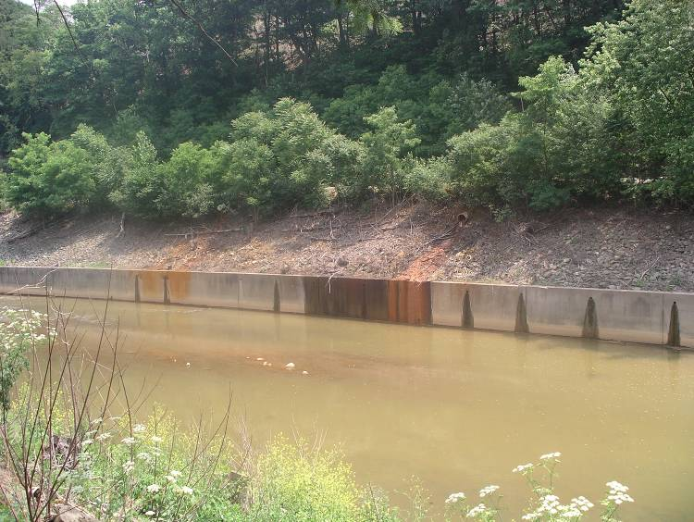

Seepage is the flow of a liquid through small openings, such as water flowing through soil. The liquid may carry with it other materials such as contaminants. The contaminated liquid may seep or flow through a permeable layer of rock or soil. When the contaminated liquid hits an impermeable layer it does not seep through it.

1. Study the Geologic Sample and label the following diagram. Label the layers of soil, gravel, sand, and clay (use the dotted lines). There may be more than one of each.

Geologic Diagram of Sample A
Gravel
1
---------------------------
Soil
2
---------------------------

3
Sand
----------------------------

4
Clay
----------------------------

5
Sand
-----------------------------

- Pour the sample of Methyl-Ethyl Death (Sample B) into Geologic Sample A. Let it sit for at least 10 minutes. What do you think will happen to the liquid? NOTE: This liquid is NOT harmful but represents a hazardous chemical that might be found on a brownfield. Student predictions should be listed here. They should mention that it may flow or seep through the layers in the Geologic Sample.
- Draw (using colored pencils) the movement of Methyl-Ethyl Death through Geologic Sample A.

1
---------------------------

2
---------------------------

3
----------------------------

4
----------------------------

5
-----------------------------

The contaminant stops moving down through the layers when it hits the clay of layer four.
4. At what layer did the Methyl-Ethyl Death stop moving through Geologic Sample A? The methyl-ethyl death stopped moving down through the layers when it hit layer number four, which is clay.

5. Why do you think the Methyl-Ethyl Death stopped moving down? The liquid stopped moving because it could not pass through the clay.__________________

6. How many layers did the Methyl-Ethyl Death go through? The methyl-ethyl death went through three layers.________________________________________________

7. Which layers of Geologic Sample A are permeable? How do you know? Layers one, two, and three are permeable because the methyl-ethyl death seeped through them.___

8. Which layers of Geologic Sample A are impermeable? How do you know? Layer 4, which is clay, is impermeable because the methyl ethyl-death did not seep through it.

9. Methyl-Ethyl-Death represents a toxic (harmful) substance that was spilled in a neighborhood. If a chemical actually spilled, or was dumped, on the soil would the contaminants stay at the top layer? Explain why or why not.

No, the contaminants would seep down through the soil just like it did in Geologic Sample A, unless the top layer was completely impermeable. It would seep down until it hit a layer of material that is impermeable. The contaminant would seep through layers of sand and soil.

10. What might happen if the contaminants seeped through the soil to underground water that was used for a drinking well? The contaminants would get into the water in the well. If people would drink the contaminated water in the well they could become ill. Eventually, the source of the sickness would have to be investigated and the well would be closed. The people would be forced to find another source of water.____

11. How does this relate to the seepage of water through a brownfield site? If the brownfield is studied and there are actual contaminants on the property, water may seep through layers of the soil in the brownfield and bring along the hazardous material from the brownfield to the groundwater in the area. It may also seep out of the brownfield site to adjacent properties, and could affect the health of plants, animals, or people who depend on food grown on the land.

Reviewer’s Signature: Rubric Score: 5,4,3,2,1

