Identify the Contaminants

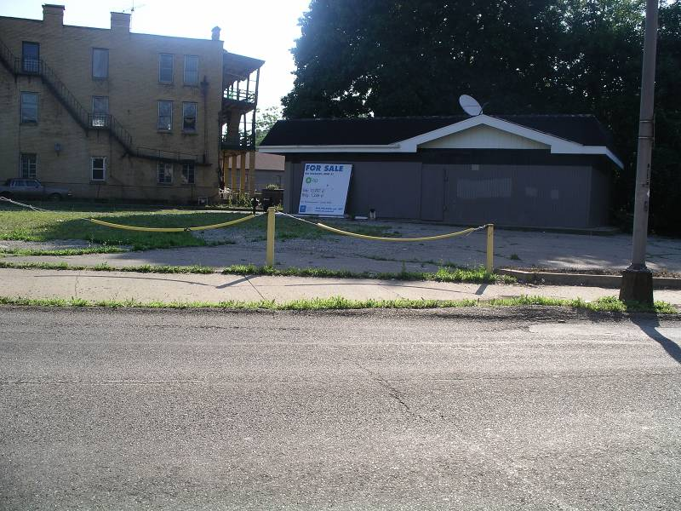

Use the EPA Contaminant Chart to answer the following.
All answers must be complete sentences.

1. How many types of brownfields are on the contaminant chart? There are twenty-three different types of brownfields listed on the contaminant chart, although there could be others that are not listed.

2. List some of the contaminants on the contaminant chart: (Many responses are possible here.) Contaminants that may be found on a brownfield site include metals, solvents, paint, gasoline and acids.

3. Does each type of brownfield have the same contaminants? Each type of brownfield does not have the same contaminants.
(5) Explain: Although some different types of brownfields may share some types of contaminants, there will usually be some contaminants that are specific to each type of brownfield.

4. Does each type of brownfield have the same number and type of contaminants? No, the number types of hazardous materials and amount of contamination on different brownfields can be different._____
(5) Explain: An example of the different amounts can be seen on the contaminant chart. Automotive repair may have six different types of contaminants whereas a machine shop may have four different types of contaminants._________________

5. Which type of brownfield may have the most types of contaminants? A railroad yard may have the most types of contaminants. The chart lists at least eleven different types of contaminants that may be found at a railroad yard, although that doesn’t mean that all abandoned railroad yards have each type of contamination.

6. If you wanted to buy an old piece of land that once had a steel mill on it what contaminants might you expect to find in the soil?

Someone would expect to find: metals, inorganics, acids, toxic compounds, semi-volatile organics including those in oil and grease, and volatile organic compounds.

If you found these contaminants on the land would it be a brownfield? Yes, if the steel mill contaminants listed on the contaminant chart were found on an unused or underused piece of land that once had a steel mill on it, it would be considered a brownfield, and tests would be necessary to determine the extent of the problem.

7. If you wanted to buy an old piece of land that once had a glass factory on it what contaminants might you expect to find?

Someone would expect to find arsenic and lead.___________________________

If you found these contaminants on the land would it be a brownfield? Yes, if the glass factory contaminants listed on the contaminant chart were found on an unused or underused piece of land that once had a glass factory on it, it would be considered a brownfield, and tests would be necessary to determine the extent of the problem.

8. If you wanted to buy an old piece of land that once had a house on it would you expect to find contaminants on it? If so what contaminants would you expect to find?

Someone would not expect to any contaminants that are listed on the chart._

If you found contaminants on the land would it be a brownfield? An old house would generally not be considered a brownfield.

9. If you wanted to buy an old piece of land that once had a research institution on it what contaminants might you expect to find?

Tests of the soil could find: organic solvents, paint, inorganic solvents, metals, metal dust, heavy metals, pesticides, photographic waste, and waste oil.
If you found these contaminants on the land would it be a brownfield? Yes, if the research institution contaminants listed on the contaminant chart were found on an unused or underused piece of land that once had a research institution on it, it would be considered a brownfield.

10. If you wanted to buy an old piece of land that once had a coal gasification company on it what contaminants might you expect to find?
Someone would expect to find: sulfur compounds, cyanide, aluminum, lead, iron, nickel, and chromium.________________________________________________

If you found these contaminants on the land would it be a brownfield? Yes, if the coal gasification contaminants listed on the contaminant chart were found on an unused or underused piece of land that once had a coal gasification plant on it, it_ would be considered a brownfield.

11. If you wanted to buy an old piece of land that once had a day cleaner on it what contaminants might you expect to find?

Someone would expect to find: spot removers, chloroform, tetrachloroethane, and perchloroethylene.

If you found these contaminants on the land would it be a brownfield? Yes, if the dry cleaner contaminants listed on the contaminant chart were found on an unused or underused piece of land that once had a dry cleaner on it, it would be considered a brownfield.

12. If you wanted to buy an old piece of land that once had a gas station what contaminants might you expect to find?

Someone would expect to find: gasoline, diesel fuel, metals, petroleum hydrocarbons, and underground storage tanks._

If you found these contaminants on the land would it be a brownfield? Yes, if the gas station contaminants listed on the contaminant chart were found on an unused or underused piece of land that once had a gas station on it, it would be considered a brownfield. Additional testing could help to determine the extent of the problem.

13. If you wanted to buy an old piece of land that once had a cosmetics manufacturing factory on it, what contaminants might you expect to find?
Someone would expect to find: heavy metals, dusts, and acids._______________
If you found these contaminants on the land, would it be a brownfield? Yes, if the cosmetics manufacturing contaminants listed on the contaminant chart were found on an unused or underused piece of land that once had a cosmetics manufacturing plant on it, it would be considered a brownfield.

14. If you wanted to buy an old piece of land that once had a battery recycling company what contaminants might you expect to find?
You might find: nickel, lead, cadmium, acids, copper, zinc, arsenic, or chromium.
If you found these contaminants on the land, would it be a brownfield? Yes, if the battery recycling contaminants listed on the contaminant chart were found on an unused or underused piece of land that once had a battery recycling center on it, it would be considered a brownfield.

15. If you wanted to buy an old piece of land that once had an apartment building on it, what contaminants might you expect to find?

Someone would not expect to find contaminants that are listed on the chart.
If you found these contaminants on the land, would it be a brownfield? It is not a brownfield._______________________________________________________

16. If you wanted to buy an old piece of land that once had a farm on it, what contaminants might you expect to find?

Someone would expect to find: copper, pesticides, insecticides, herbicides, grain_ fumigants, and arsenic._______________________________________________
If you found these contaminants on the land, would it be a brownfield? Yes, if the farm contaminants listed on the contaminant chart were found on an unused or___ underused piece of land that once had a farm on it, it would be considered a brownfield.

17. If you wanted to buy an old piece of land that once had a railroad yard on it, what contaminants might you expect to find?

Someone would expect to find: petroleum hydrocarbons, benzene, toluene, PCB’s ethylbenzene, xylene, solvents, fuels, lead, oil, and grease.________________

If you found these contaminants on the land, would it be a brownfield? Yes, if the railroad contaminants listed on the contaminant chart were found on an unused or underused piece of land that once had a railroad on it, it would be considered a brownfield, and should be tested to determine what type of remediation efforts can make the land safe for humans.

18. If you wanted to buy an old piece of land that once had a supermarket on it, what contaminants might you expect to find?
Someone would not expect to find contaminants that are listed on the chart.
If you found these contaminants on the land, would it be a brownfield? An abandoned supermarket is generally not expected to be a brownfield.__

