Identify the Contaminants

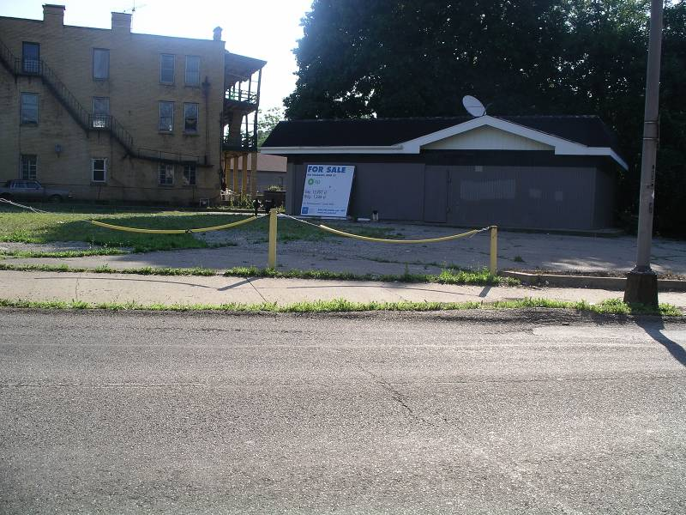

Use the EPA Contaminant Chart to answer the following.
All answers must be complete sentences.

1. How many types of brownfields are on the contaminant chart?

2. List some of the contaminants on the contaminant chart:

3. Does each type of brownfield have the same contaminants?

4. Does each type of brownfield have the same number and type of contaminants?

(5) Explain:

5. Which type of brownfield may have the most types of contaminants?

6. If you wanted to buy an old piece of land that once had a steel mill on it, what contaminants might you expect to find in the soil?

If you found these contaminants on the land, would it be a brownfield?

7. If you wanted to buy an old piece of land that once had a glass factory on it, what contaminants might you expect to find?

If you found these contaminants on the land, would it be a brownfield?

8. If you wanted to buy an old piece of land that once had a house on it would you expect to find contaminants on it? If so, what contaminants would you expect to find?

If you found contaminants on the land, would it be a brownfield?

9. If you wanted to buy an old piece of land that once had a research institution on it, what contaminants might you expect to find?

If you found these contaminants on the land, would it be a brownfield?

10. If you wanted to buy an old piece of land that once had a coal gasification company on it, what contaminants might you expect to find?

If you found these contaminants on the land, would it be a brownfield?

11. If you wanted to buy an old piece of land that once had a dry cleaner on it, what contaminants might you expect to find?

If you found these contaminants on the land, would it be a brownfield?

12. If you wanted to buy an old piece of land that once had a gas station on it, what contaminants might you expect to find?

If you found these contaminants on the land, would it be a brownfield?

13. If you wanted to buy an old piece of land that once had a cosmetics manufacturing factory on it, what contaminants might you expect to find?

If you found these contaminants on the land, would it be a brownfield?

14. If you wanted to buy an old piece of land that once had a battery recycling company on it, what contaminants might you expect to find?

If you found these contaminants on the land, would it be a brownfield?

15. If you wanted to buy an old piece of land that once had an apartment building on it, what contaminants might you expect to find?

If you found these contaminants on the land, would it be a brownfield?

16. If you wanted to buy an old piece of land that once had a farm on it, what contaminants might you expect to find?

If you found these contaminants on the land, would it be a brownfield?

17. If you wanted to buy an old piece of land that once had a railroad yard on it, what contaminants might you expect to find?

If you found these contaminants on the land, would it be a brownfield?

18. If you wanted to buy an old piece of land that once had a supermarket on it, what contaminants might you expect to find?

If you found these contaminants on the land, would it be a brownfield?

