I SEE TAIWAN FILM FESTIVAL “看見臺灣” 電影展
Saturday, November 5, 2016 at Carnegie Mellon University

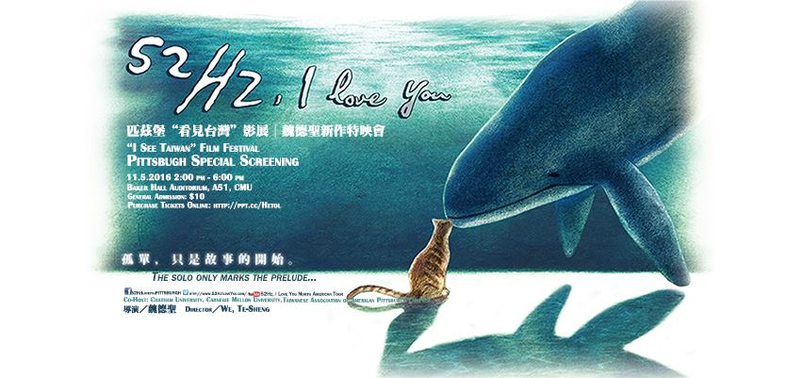

Carnegie Mellon University welcomes renowned Taiwanese Director, WEI Te-Sheng
魏德聖, ranked the #1 Mandarin director in 2014 for his blockbuster hits such as Cape 7, Seediq Bale, and Kano. From Oct. 29 to Nov. 21, 2016 director WEI’s newest movie “52Hz, I love you” will screen across 50+ locations in North America. On Saturday,
Nov. 5, 2016 it will screen in Pittsburgh on the CMU campus!

Date: Saturday, 11/5/2016
Time: 2:00 pm to 6:00 pm, the doors open at 1:30
Location: The Giant Eagle Auditorium (BH A51), CMU.
5000 Forbes Avenue, Pittsburgh, PA 15213
General admission: $10
Event Organizers: Chia-yen Lin (IUP), Tingting Rachel Chung (Chatham Univ.) &
Sue-mei Wu (CMU)

Special Thanks : Pittsburgh Chinese Restaurant Association; Asian Studies Center, Univ. of Pittsburgh; Dept. of Modern Languages, CMU; Chatham University; CLTA-WPA. Taiwanese Association of America-Pittsburgh Chapter.

Agenda:
2:00: I See Taiwanese Opera & Puppetry

Short documentary films produced by Sue-mei Wu & Estelle Tian (CMU):
Introduction to Taiwanese Opera 歌仔戲; Taiwanese Opera Superstar: Yang Li-hua
楊麗花 & Introduction to Taiwanese Hand Puppet Theater 布袋戲

Speaker: Sue-mei Wu 吳素美, Ph.D. Teaching Professor of Chinese Studies &
Director, MA in Applied SLA, Dept. of Modern Languages, Carnegie Mellon University
Website:http://xinterra.com/suemeiwu

3:00: 52Hz, I love you (Directed by WEI Te-sheng 魏德聖), Pittsburgh Special Screening

5:00: Post-Screening Discussion
Moderator: Tingting Rachel Chung, Ph.D. Director of Business Programs, Chatham University
6:00 Closing

Information about the “52Hz, I Love You” film’s North American Tour‬‬‬‬‬‬‬‬‬‬‬  Film Classification: PG-13; Language: Mandarin with English subtitles | ‬  Subscribe40‬‬‬‬‬‬

睽違已久，魏德聖導演最新作品──台灣首部音樂劇電影《52Hz, I Love You》，以原創曲樂與大膽起用充滿魅力的新生代演員來詮釋台北都會愛情故事。繼《賽德克巴萊》和《KANO》的豪華盛宴後,《52Hz, I Love You》這部清新小品宛如精緻的下午茶甜點，讓觀眾享有滿滿的甜蜜幸福感！不僅讓人重溫《海角七號》的感動，在動人的音樂旋律中，傳遞快樂、幸福，找回「愛」的勇氣與美好！‬‬‬此次，全北美洲有超過40個城市參與，規劃了將近70場次，藉由選擇在北美各城市全球首映，表達對台灣鄉親力挺台灣電影的感謝，希望感動北美台灣鄉親的心，也期待透過電影、音樂、演員等多樣性的交流，讓更多人看見現代化的台北樣貌和人們生活其中的感受。‬
‬
“52Hz” is a very unusual frequency sung by the loneliest whale in the world. The mysterious pitch is like no other; the song sounds like crying out for companionship that never comes. The Taiwan musical film “52Hz, I Love You” is set in Taipei, a bustling city with millions of lonely people seeking love. ‬

Video Messages about “52Hz, I Love you”:
52Hz, I love you: The Solo Only Marks the Prelude
https://www.youtube.com/watch?v=uhUXXi-EfRs

WEI's Message to Taiwanese in North America
https://www.youtube.com/watch?v=R0KhGKTd_p8

‬Facebook: 52HzIloveyouPittsburgh/

