SUCCEED teacher workshop 2013

Bathtub Analogy – Discussion

In the bathtub analogy, explain what is represented by each of the following:

Greenhouse Gas Analogy | Energy Analogy
- The bathtub
- The water
- The flow rate of water entering the bathtub (faucet)
- The flow rate of water leaving the bathtub (drain)
- Clogging of bathtub drain
- The level of water in the bathtub
- The change in the flow rate of water leaving the bathtub
- The underlying cause of the change in the flow rate of water leaving the bathtub
- Water spilling over the side of the bathtub

Exercises Greenhouse Gas Analogy

- Assume that the mass of carbon dioxide equivalent (CO_{2e}) entering the atmosphere continues indefinitely at the current levels of 7 GT of CO_{2e}/year. Show this flat rate on the graph below. Now draw another flow rate curve for CO_{2e} leaving the atmosphere versus time. Show how it will reach a dynamic equilibrium. Indicate on the time-axis the amount of years that will take (100, 1,000, 10,000, even more?)

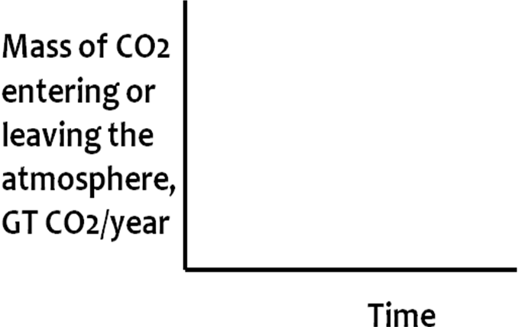

- Consider the total mass of CO_{2e} in the atmosphere at any given time. Draw a curve showing this total mass versus time based on the curves you drew in the previous exercise.

