My Travel as a Drop of Water

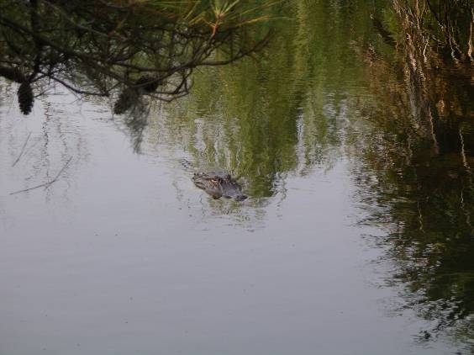

Liquids can change their state of matter. Water can evaporate to become a gas (water vapor). We sometimes see water vapor as steam, fog, or clouds. Water vapor becomes a liquid again by condensing. A good example of condensation is rain. Water that is frozen is ice.

Complete the story below to review the Water Cycle, and why this is important when thinking about brownfields. Use key terms such as
evaporated, condensed, permeable, groundwater, rain, seeped

I am a simple drop of water, and this is my story. One day I was at home, in Someplace, Pennsylvania, sitting on the couch watching television. I must have fallen asleep. When I woke up I was a water vapor high up in the sky. I must have to turn into a gas. Suddenly I and fell to the ground with the . I passed through
the top layer of the earth easily since it was . Before I into the ground, I noticed some signs that said a steel mill had been on the land sometime in the past. It said that the land was a brownfield and that the dirt was probably contaminated with some hazardous chemicals and metals. I mixed with acids and toxic compounds. I seeped through the soil, carrying the contaminants to the below the surface of the earth. I hope people realize this and don’t drink the water! Pretty soon, I’ll
and the whole cycle will start again!

