Car Wash – Student Pages

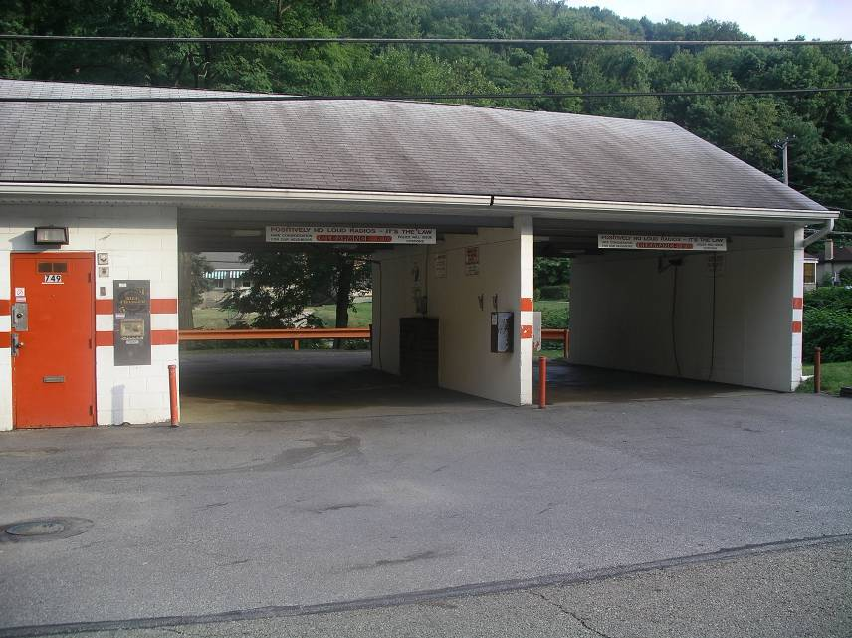

You want to build a carwash on an empty piece of land that is considered a brownfield. The piece of land is located in Anytown, Pennsylvania. The land looks like it might have once had a gas station on it. When you check on the price of the land you learn that you can buy it for only $5,000.00. A piece of land in McKees Rocks this large would normally cost about $100,000.00. Somebody tells you that there might be money available to help you with the cleanup and development of the land, and suggests that you look into this.
(Answer the following in sentence form, using additional paper if necessary.)

1. What research would you have to do before you decide whether to build a car wash on this property?

(5)

2. What are some methods of cleaning (remediating) the property that might be used?

(5)

3. What would building this car wash do to improve the community?

(5)

4. What would you name your new car wash business?

